**Exploring Web Development with Python: A Comprehensive Study with Applications (Blog) Built in Flask and Django**

Julia Gongala

B00402569

School of Computing, Engineering

and Physical Sciences

BSc (Honours) Web and Mobile Development

University of the West of Scotland

Supervisor: Tony Gurney

Moderator: Pablo Salva Garcia

# Declaration

This dissertation is submitted in partial fulfillment of the requirements for the degree of Web and Mobile Development (Honours) in the University of the West of Scotland.

I declare that this dissertation embodies the results of my own work and that it has been composed by myself. Following normal academic conventions, I have made due acknowledgement to the work of others.

Name: Julia Krystyna Gongala

Signature: J. Gongala

Date: 27th March 2024

**COMPUTING HONOURS PROJECT SPECIFICATION FORM**

*(Electronic copy available on the Aula Computing Hons Project Site)*

**Project Title:** "Exploring Web Development with Python: A Comprehensive Study with Applications (Blog) Built in Flask and Django."

**Student:** Julia Gongala  **Banner ID:** B00402569

**Programme of Study:** BSc (Hons) in Web and Mobile Development

**Supervisor:** Tony Gurney

**Moderator:** Pablo Salva Garcia

**Outline of Project:** *(a few brief paragraphs)*

Web development is a cornerstone of the digital age, driving the way we interact with information and services on the internet. In this dynamic landscape, Python, renowned for its versatility and user-friendly syntax, has emerged as a powerhouse for web application development. This dissertation embarks on an exciting journey, offering a comprehensive study enriched with hands-on applications. Our focal point is the creation of a fully functional blog website, a journey we undertake using two prominent Python web frameworks: Flask and Django.

Python's selection as the centrepiece of this exploration is not arbitrary but rooted in its growing popularity among developers. Python's elegant and readable syntax, coupled with a vast ecosystem of libraries and frameworks, has propelled it into the forefront of web development. Its seamless integration with web frameworks makes it an ideal choice for building robust and feature-rich web applications. Flask and Django, two noteworthy representatives of Python's web development prowess, each bring their unique strengths to the table, making them ideal subjects for this comprehensive study.

Our voyage commences with a brief introduction to the expansive realm of web development and Python's pivotal role within it. We set the stage for a deeper dive into Flask and Django, shedding light on their significance in the web development landscape.

As we navigate this study, we combine theoretical insights with hands-on practice. Our primary objective is to construct a functional blog website using both Flask and Django, unravelling their capabilities and dissecting their inner workings. This project-based approach ensures that we not only grasp the theoretical concepts but also gain practical experience in creating web applications. We explore the steps required to set up development environments, configure databases, implement user authentication, and craft user-friendly interfaces.

Furthermore, we undertake a comparative analysis of Flask and Django, offering a nuanced understanding of their strengths and limitations. This analysis empowers developers to make informed decisions when selecting the most suitable framework for their specific projects. It serves as a testament to Python's adaptability, showcasing how it caters to diverse web development needs.

Deployment, testing, and debugging, crucial facets of web development, receive their due attention in this exploration. We explore various deployment options for Flask and Django applications, ensuring that our web projects transcend the realm of local development environments and reach a global online audience.

In addition, we address the critical issue of web application security, examining common vulnerabilities and emphasizing best practices for mitigation. This discussion underscores the significance of secure coding practices within the context of web development with Python.

In conclusion, Exploring Web Development with Python: A Comprehensive Study with Applications (Blog) Built in Flask and Django embarks on a captivating journey through the expansive world of web development with Python. It underscores Python's pivotal role in this domain and showcases the capabilities of Flask and Django through the creation of a fully functional blog website. By the culmination of this exploration, readers will possess not only the knowledge but also the practical skills to embark on their web development ventures confidently or make informed choices when selecting the right framework for their projects.

**A Passable Project will:**

* Introduction to Web Development and Python
* Flask and Django Introduction
* Building basic Blog with Flask and Django where user will be able to add, delete, edit and see posts to compare both frameworks and select better for advanced blog.
* Comparative Analysis for both frameworks showing their features.
* Deployment and Testing of the application

**A First Class Project will:**

* Framework Comparison and Analysis. A detailed and insightful comparison between Flask and Django, highlighting not only their strengths and weaknesses but also their suitability for specific use cases – Blog using literature review and blog development
* Advanced Blog Development. A feature-rich and highly polished blog application built using selected framework, that has been chosen through comprehensive study to justify all arguments and decision, demonstrating not only the core functionality (CRUD) but also advanced features like user profiles, or uploading images. Advanced blog will incorporate modern practices and techniques.
* Demonstration Knowledge. A clear demonstration of knowledge in modern web development, Python, Flask, Django, and related popular technologies.
* Using References and Citations. Accurate and extensive citation and referencing of all sources, demonstrating a deep understanding of the academic context.

**Reading List:**

* *"Django for Beginners"* by William S. Vincen
* *"Django for APIs"* by William S. Vincent
* *"Two Scoops of Django 3.x"* by Daniel Roy Greenfeld and Audrey Roy Greenfeld
* *"Flask Web Development"* by Miguel Grinberg
* *"Flask By Example"* by Gareth Dwyer
* *"Building RESTful Python Web Services"* by Gaston C. Hillar
* *"Python Web Development with Django"* by Jeff Forcier, Paul Bissex, and Wesley Chun
* *"Test-Driven Development with Python"* by Harry J.W. Percival
* Django Official Documentation
* Flask Official Documentation

**Resources Required:** *(hardware/software/other)*

* Personal workstation with Visual Studio Code and Python installed
* Git and GitHub for version control and collaboration.
* Web browser for research and testing.
* Hosting platform (e.g., Heroku, AWS, or a VPS) for deployment.
* Testing tools

**Marking Scheme: Marks**

Introduction 5%

Literature Review 15%

Development 30%

Comparative Analysis 30%

Testing 10%

Conclusion 10%

**AGREED:**

**Student Supervisor Moderator**

**Name:** Julia Gongala  **Name:** Tony Gurney **Name:** Pablo Salva Garcia

**IMPORTANT:**

1. ***By agreeing to this form all parties are confirming that the proposed Hons Project will include the student undertaking practical work of some sort using computing technology / IT, most frequently achieved by the creation of an artefact as the focus for covering all or part of an implementation life-cycle.***
2. ***By agreeing to this form all parties are confirming that any potential ethical issues have been considered and if human participants are involved in the proposed Hons Project then ethical approval will be sought through approved mechanisms of the School of CEPS Ethics Committee.***

Table of Contents

Declaration 2

Table of Figures 8

Acknowledgements 9

Abstract 10

1. Introduction 11

2. Background 14

2.1 Background of web application development 14

2.1.1 Front – End Development 14

2.1.2 Back – End Development 15

2.1.3 Full – Stack Development 15

2.1.4 Responsive Design 16

2.1.5 Security 17

2.2 Front - End Technologies 18

2.2.1 HTML 18

2.2.2 CSS 19

2.2.3 JavaScript 19

2.3 Back - End Technologies 20

2.3.1 PHP 20

2.3.2 Ruby 20

2.3.3 Java 20

2.3.4 C++ 21

3. Python 22

3.1 Django 23

3.2 Flask 24

3.3 FastAPI 25

3.4 Bottle 25

3.5 Pyramid 26

4. User-Centric Design and System Requirements 27

4.1 Design and Requirements 27

4.1.1 Universal Design 27

4.1.2 Universal Design Storyboard 29

4.1.2.1 Landing Page / Home Page 29

4.1.2.2 Register Page 29

4.1.2.3 Login Page 30

4.1.2.4 Community/Posts Page 30

4.1.2.5 Add Post Page 30

4.1.2.6 Edit Post Page 30

4.1.3 Database Design – EER Diagram 30

5. Comprehensive analysis 30

5.1 Flask 31

5.1.1 Design Philosophy 31

5.1.2 Routing and Request Handling in Flask 32

5.1.3 Template Engines in Flask 35

5.1.4 Database Integration 36

5.1.5 User Authentication and Authorization in Flask 38

5.1.6 Testing in Flask 38

5.1.7 Community and Ecosystem 39

5.1.8 Scalability and Performance 40

5.2 Django 41

5.2.1 Design Philosophy 41

5.2.2 Routing and Request Handling in Django 42

5.2.3 Template Engines in Django 45

5.2.4 Database Integration 46

5.2.5 User Authentication and Authorization in Django 47

5.2.6 Testing in Django 48

5.2.7 Community and Ecosystem 49

5.2.8 Scalability and Performance 50

5.2.9 Build-in features 50

5.3 Flask and Django Deployment 53

5.4 Conclusion 54

6. Advanced Blog 55

6.1 Database Development 55

6.2 Authentication and Authorisation 57

6.2.1 Authentication 57

6.2.2 Authorisation 58

6.2.3 Custom Implementation 58

References 60

# Table of Figures

Figure 1 Growth of major programming languages (StackOverflow, 6/09/2017) 12

Figure 2 How Front-end development works (frontendmasters.com, n/d) 14

Figure 3 How back-end development works (codeburst.io, 29/07/2020) 15

Figure 4 Complete Stack Development in an End-to-End Workflow(mongodb.com, n/d) 16

Figure 5 Django and Flask in Top 15 frameworks (survey.stackoverflow.co, 2023) 23

Figure 6 Django official logo (djangoproject.com, n/d) 23

Figure 7 Flask official logo (wikipedia.org, n/d) 24

Figure 8 Home Page with Login From - any user view 27

Figure 9 Register Page 28

Figure 10 Home page for authorised user 28

Figure 11 Create Post Page 29

Figure 12 Directory Structure of Flask Web Application 32

Figure 13 Routing in Flask Web Application 33

Figure 14 Request in Flask Web Application 34

Figure 15 Jinja2 - example of syntax 35

Figure 16 Database in Flask 37

Figure 17 Directory Structure of Django Web Application 42

Figure 18 Routing in Django Web Application 43

Figure 19 Registered routing in Django Web Application 43

Figure 20 Request in Django Web Application 44

Figure 21 Models in Django 47

Figure 22 Admin Interface 51

Figure 23 Class Form Declaration 51

Figure 24 Register form created by Django feature 52

Figure 25 Crispy forms with CSRF 52

Figure 26 Heroku package 53

Figure 27 Requirements Install 53

Figure 28 Procfile declaration 54

Figure 29 Heroku dashboard with current sites 54

Figure 30 Advanced Blog - Category Model 56

Figure 31Advanced Blog - Post Model 56

Figure 32 Advanced Blog - Comments Model 56

Figure 33 Advanced Blog - imported User Model 57

Figure 34 Authentication - registration form 57

Figure 35 The registration view 58

Figure 36 register.html 58

# Acknowledgements

I would like to express my heartfelt gratitude to my parents for their unwavering support and encouragement in all aspects of my work. A special thanks to my boyfriend, David, for dedicating his time, providing continuous support, and engaging in long, meaningful discussions about my ideas and challenges. I am also grateful to my supervisor, Tony, whose previous guidance in Python language has been instrumental in shaping my journey in this research topic. Lastly, a big thank you to my moderator, Pablo, for his ongoing support.

# Abstract

In the realm of web development, Python has emerged as a powerhouse, valued for its simplicity, readability, and robust ecosystem. This research undertakes a thorough exploration of Python's pivotal role in web development, focusing on its frameworks, libraries, and practical applications. As scalable and efficient web solutions become increasingly sought after by businesses, a nuanced understanding of Python becomes imperative.

The intricacies of Python's contributions to web development are delved into, shedding light on its flagship frameworks, namely Django and Flask. Through real-world implementations, the aim is to showcase how these frameworks empower developers to create robust and maintainable web applications. The examination extends beyond the server-side, exploring Python's seamless integration with front-end technologies, providing a holistic perspective on its position in the dynamic landscape of contemporary web development.

The proposed technologies and features are meticulously tailored to address the project's goals. Django, with its batteries-included philosophy, offers a comprehensive and structured approach to building web applications, ensuring scalability and maintainability. Flask, on the other hand, provides a lightweight and flexible framework, ideal for smaller projects or when customization is paramount.

Furthermore, the research emphasizes the integration of Python with front-end technologies. This integration ensures a cohesive development experience, allowing for the creation of interactive and responsive user interfaces.

In practical terms, the study will provide developers and businesses with actionable insights into leveraging Python's strengths for optimal web development outcomes. Whether through the powerful abstractions of Django or the lightweight agility of Flask, Python's versatility is harnessed to meet the diverse needs of modern web applications. As businesses navigate the complexities of the digital landscape, understanding the intricacies of Python in web development becomes not only beneficial but essential for achieving success in delivering scalable, efficient, and user-friendly web solutions.

Flask blog: <https://flask-blog-dc8190c49fbf.herokuapp.com/>

Django blog: <https://basic-django-blog-06d8c3506d11.herokuapp.com/>

Advanced blog: <https://advanced-blog-3a0e11627526.herokuapp.com/>

# Introduction

The evolution of programming languages has indeed been marked by a captivating journey, reflecting the dynamic nature of technology and the ever-changing landscape of the computing industry. As time progresses, the narrative of programming languages becomes more intricate, characterized by the emergence of new paradigms, tools, and methodologies.

In the 1960s and 1970s, the advent of high-level programming languages like Fortran, Lisp, and COBOL was witnessed, aiming to enhance productivity and portability. Scientific and engineering computations were the focus of Fortran, while Lisp pioneered the concept of symbolic expressions and recursion, and COBOL targeted business applications. The groundwork laid by these languages set the stage for subsequent innovations and the development of more user-friendly programming languages.

The 1980s and 1990s ushered in the era of personal computing, giving rise to languages like C, C++, and Java. System programming saw C as the language of choice due to its low-level capabilities, while C++ introduced object-oriented programming concepts, adding a layer of abstraction. Java, designed for platform independence, gained popularity for developing applications that could run on any device with a Java Virtual Machine (JVM).

In the late 1990s and early 2000s, dynamic languages such as Python and Ruby emerged, emphasizing simplicity and readability. Widespread acceptance of Python was driven by its clear syntax and versatility. Simultaneously, JavaScript rose to prominence as the scripting language for web browsers, enabling dynamic and interactive web pages.

As the internet continued to evolve, the demand for web development languages and frameworks increased. PHP, alongside Python and Ruby, played a crucial role in server-side scripting, powering dynamic web applications. The shift towards more responsive and interactive web experiences was marked by the introduction of AJAX (Asynchronous JavaScript and XML).

The rise of mobile computing in the 2010s led to the prominence of languages like Swift for iOS and Kotlin for Android development. New avenues for building mobile applications efficiently were provided by the development of cross-platform frameworks such as React Native and Flutter. (Karunanayake, Feb 24, 2023)

A critical aspect of modern programming revolves around the indispensable role of frameworks. These frameworks serve as pivotal tools, furnishing developers with pre-built structures and utilities that significantly streamline the development process. Distinguished by their unique syntax and architecture, these frameworks provide a higher level of abstraction. This, in turn, empowers programmers to direct their focus towards crafting application-specific logic, alleviating the need to grapple with intricate low-level details.

While the adoption of various frameworks may initially present a learning curve, the adaptability of programmers becomes paramount. It is through this adaptability that developers can harness the distinctive advantages that each framework brings to the table. Embracing the diversity of frameworks is not just a necessity; it is a strategic approach that enables developers to optimize their workflow, enhance productivity, and build robust and efficient software solutions tailored to the specific needs of their projects. As the programming landscape continues to evolve, the ability to navigate through different frameworks and judiciously select the most suitable one for a given task emerges as a valuable skill for developers aiming to stay at the forefront of innovation.

Collaboration among programmers, particularly within diverse teams, presents a multifaceted challenge that hinges on clear communication and unified practices. In this intricate landscape, the strategic choice of frameworks becomes pivotal, serving as a cornerstone for harmonizing team expertise and aligning with project requirements. The aim is to establish an environment where collaboration can flourish seamlessly.

The significance of framework selection is underscored by its impact on the team's ability to work cohesively. When frameworks are chosen with consideration for the team's proficiency and project specifications, it lays the groundwork for an efficient collaboration process. A well-aligned framework not only facilitates smoother communication but also enables developers to leverage their expertise, fostering a sense of shared understanding within the team.

However, the integration of disparate frameworks within a project introduces an additional layer of complexity. This complexity necessitates the establishment of seamless communication channels and a shared comprehension of the chosen frameworks among team members. This shared understanding becomes paramount to ensure a cohesive and productive development environment, where team members can collaborate without unnecessary friction or misunderstandings.

In essence, successful collaboration in programming teams is not only contingent on effective communication but also on the thoughtful selection and integration of frameworks. By aligning frameworks with team expertise and project needs, and fostering a shared understanding, development teams can navigate the challenges of diverse collaborations more effectively, resulting in streamlined workflows and successful project outcomes.

The intricate interplay of challenges and solutions within the programming landscape serves as a compelling backdrop for thesis, titled 'Exploring Web Development with Python: A Comprehensive Study with Applications (Blog) Built in Flask and Django.' This research delves into the dynamic realm of web development, placing a particular emphasis on Python, a versatile programming language that has witnessed remarkable growth, as illustrated in Figure 1.

Figure 1 Growth of major programming languages (StackOverflow, 6/09/2017)

As depicted in Figure 1.1, Python has experienced substantial popularity in recent years, emerging as a leading choice among developers for various applications. The thesis aims to unravel the factors contributing to Python's ascendancy in the programming landscape, exploring its versatility and adaptability in the context of web development.

Within the scope of this research, our focus is directed towards two prominent web frameworks Flask and Django. An in-depth study is conducted to elucidate their distinct features, strengths, and applications. Practical examples and the undertaking of blog development serve the purpose of showcasing how these frameworks contribute to the creation of dynamic and robust web applications.

The strategic choice of Flask, renowned for its simplicity and flexibility, alongside Django, celebrated for its batteries-included approach, sets the stage for a comparative analysis. This approach not only brings to light the unique attributes of each framework but also provides insights into the trade-offs involved in selecting a framework based on specific project requirements. Through hands-on exploration and real-world application, the research endeavours to offer a nuanced understanding of how Flask and Django cater to different aspects of web development, enabling developers to make informed choices aligned with their project goals.

Moreover, the challenges and benefits associated with integrating these frameworks into collaborative web development projects are delved into by the study. Emphasis is placed on the importance of clear communication and shared understanding among team members, highlighting the necessity for cohesive collaboration when working with diverse frameworks. Addressing the collaborative aspects of web development, the research aims to contribute practical insights that extend beyond individual proficiency with the frameworks, recognizing the significance of teamwork in achieving successful project outcomes.

In essence, the aspiration of this study is to be a valuable resource for programmers and developers navigating the evolving landscape of web development using Python and its associated frameworks. Through a comprehensive exploration of Flask and Django, coupled with practical examples and a focus on collaborative dynamics, professionals are equipped with the knowledge and perspectives needed to thrive in the dynamic and ever-changing world of web development.

# Background

## Background of web application development

Web application development is a multifaceted process that involves creating and maintaining software applications accessible through web browsers. It encompasses both front-end and back-end components, each playing a crucial role in delivering a seamless and interactive user experience.

### Front – End Development

The front end, often referred to as the client-side, constitutes the user interface (UI) and user experience (UX) layer of a web application. It is the part of the application that users directly interact with, encompassing elements like buttons, forms, and visual components. Figure 2 illustrates the communication flow between the front end and back end, showcasing how user interactions are processed and data is exchanged.

Figure 2 How Front-end development works (frontendmasters.com, n/d)

Front-end development primarily relies on three fundamental technologies: HTML (Hypertext Markup Language), CSS (Cascading Style Sheets), and JavaScript. HTML serves as the backbone, structuring the content and defining the page's semantic structure. CSS comes into play for styling, determining the layout, colours, and overall visual presentation of the web pages. JavaScript, on the other hand, introduces interactivity, enabling developers to create dynamic and responsive user interfaces.

The integration of these technologies allows front-end developers to craft visually appealing and user-friendly experiences. HTML provides the skeletal structure, CSS adds the aesthetic layer, and JavaScript injects behaviour and responsiveness, creating a cohesive and engaging user interface. (Robbins, 2018)

The evolution of front-end development has seen the emergence of powerful frameworks such as React, Angular, and Vue.js. These frameworks provide a structured and organized approach to building web applications, facilitating the development process and enhancing application performance. React, developed by Facebook, utilizes a component-based architecture, Angular, maintained by Google, is a comprehensive framework, and Vue.js, known for its simplicity, offers a flexible and adaptable solution. These frameworks help manage the complexity of large-scale applications, promote code reusability, and ensure efficient rendering of UI components.

Moreover, front-end development has been further streamlined by the use of JavaScript libraries and tools. Libraries like jQuery simplify DOM manipulation, making it easier for developers to interact with the document object model. Task runners and bundlers like Webpack assist in optimizing and organizing code, improving performance and maintainability. (Lolugu, 2023)

In conclusion, front-end development is a crucial aspect of web application creation, focusing on delivering seamless and visually appealing user experiences. The utilization of HTML, CSS, and JavaScript, along with modern frameworks and libraries, empowers developers to build interactive and dynamic interfaces, ultimately enhancing the overall usability and success of web applications.

### Back – End Development

Back-end development, also known as server-side development, plays a pivotal role in shaping the functionality and performance of web applications. It encompasses the creation of servers, databases, and application logic that power the front end and this could be seen on Figure 3. Essential to managing and storing data, handling business logic, and executing server-side operations, back-end development employs various programming languages such as Python, Ruby, Java, and PHP, along with server technologies like Node.js. The choice of databases, such as MySQL, PostgreSQL, and MongoDB, is crucial for efficient data storage and retrieval.

Figure 3 How back-end development works (codeburst.io, 29/07/2020)

As noted by renowned software developer and author Martin Fowler in 1999, any fool can write code that a computer can understand. Good programmers write code that humans can understand. This underscores the significance of writing clear and maintainable code in the back end, ensuring scalability and long-term viability of a web application. Clear, human-readable code promotes collaboration, ease of debugging, and facilitates future modifications or updates. (Martin Fowler, 1999)

Frameworks play a crucial role in simplifying and expediting the back-end development process. Popular frameworks like Django (Python), Ruby on Rails (Ruby), and Express.js (Node.js) provide pre-built modules and structures. These frameworks adhere to best practices, enhancing the efficiency and reliability of back-end development. They not only expedite the development process but also contribute to the creation of robust and scalable applications. (Rose, 2020)

In recent years, the demand for scalable and efficient back-end systems has driven the development of microservices architecture. This approach involves breaking down applications into smaller, independent services that communicate with each other, promoting flexibility, scalability, and ease of maintenance. The shift towards containerization and orchestration tools such as Docker and Kubernetes further aids in deploying, scaling, and managing back-end services seamlessly.

### Full – Stack Development

The roots of Full Stack Development can be traced back to the need for more streamlined and efficient development processes. As web applications grew in complexity, with an increasing demand for seamless user experiences and real-time interactions, the traditional siloed approach became a bottleneck. Full Stack Development addresses this challenge by empowering developers with a comprehensive skill set that spans the entire application stack. This encompasses not only proficiency in front-end technologies such as HTML, CSS, and JavaScript but also expertise in back-end languages, databases, server management, and API integration. (Mcfarland, 2014). Figure 4 illustrates the concept of Complete Stack Development in an End-to-End Workflow.

Figure 4 Complete Stack Development in an End-to-End Workflow(mongodb.com, n/d)

Frameworks play a pivotal role in shaping the Full Stack Development landscape. They provide pre-built components and tools that expedite development, ensuring a standardized and efficient workflow. Examples such as MEAN (MongoDB, Express.js, Angular, Node.js) and MERN (MongoDB, Express.js, React, Node.js) represent Full Stack Development frameworks that have gained popularity for their ability to seamlessly integrate various technologies across the entire stack. (MongoDb, 2021)

The advent of microservices architecture has further catalysed the evolution of Full Stack Development. Microservices break down monolithic applications into smaller, independently deployable services, allowing developers to work on specific components of the application stack without disrupting the entire system. This modular approach aligns well with the Full Stack Development ethos, enabling developers to build and scale applications more efficiently. (Richardson, 2019)

In conclusion, Full Stack Development has emerged as a pivotal approach in the realm of web application development, responding to the demand for versatile and skilled developers. The evolution of this paradigm reflects the ever-changing landscape of technology and the need for holistic solutions to complex challenges. As the digital ecosystem continues to evolve, Full Stack Development is likely to remain a cornerstone, empowering developers to navigate the intricacies of both front-end and back-end development seamlessly.

### Responsive Design

Responsive design has emerged as an indispensable component of contemporary web application development, driven by the necessity to accommodate an increasingly diverse array of devices and screen sizes accessing online content. Ethan Marcotte, in his seminal work "Responsive Web Design," introduced the concept, emphasizing the need for websites to adapt seamlessly to various devices, from smartphones to desktop monitors. The traditional approach of creating separate versions for different devices proved impractical as the digital landscape continued to evolve. (Marcotte, 2010)

A cornerstone principle of responsive design involves the implementation of fluid grids. Marcotte advocates for the use of relative units like percentages instead of fixed units, allowing content to flexibly expand or contract within its container to fill the available space (Marcotte, 2010). This ensures that web applications maintain a cohesive structure and readability across different screen sizes.

Flexible images, as championed by web designer Brad Frost in "Atomic Design," are another critical aspect of responsive design. Frost underscores the importance of employing CSS techniques to ensure that images scale proportionally, adapting seamlessly to diverse screen dimensions (Frost, 2016).This approach prevents issues such as image overflow or pixelation and contributes to an optimal user experience.

Media queries, a key feature of responsive design, enable developers to apply specific styles based on the characteristics of the user's device. By defining breakpoints in the code, developers can create responsive layouts that adjust to varying screen widths, heights, and resolutions. This level of customization ensures that web applications not only adapt to different devices but also prioritize usability and visual aesthetics (Marcotte, 2010).

In conclusion, responsive design stands as a fundamental element in the backdrop of web application development, offering a solution to the challenges posed by the ever-expanding diversity of devices. It empowers developers to create adaptive, user-friendly applications that deliver a consistent and engaging experience across the dynamic landscape of digital platforms.

### Security

Security is a paramount concern in the backdrop of web application development, given the increasing frequency and sophistication of cyber threats. As web applications become integral to various aspects of daily life, from online banking to healthcare services, ensuring the confidentiality, integrity, and availability of user data is imperative. The Open Web Application Security Project (OWASP) provides a comprehensive guide, "OWASP Top Ten," highlighting the most critical web application security risks. Common vulnerabilities, such as injection attacks, cross-site scripting (XSS), and broken authentication, underscore the need for robust security practices (OWASP, 2021).

Authentication and authorization mechanisms play a pivotal role in securing web applications. Implementing secure user authentication, multi-factor authentication (MFA), and proper authorization controls are essential steps to prevent unauthorized access and protect sensitive user data. Security protocols, such as OAuth 2.0 and OpenID Connect, provide standardized frameworks for secure authentication and authorization in web applications (Hardt, 2012).

Additionally, the use of secure coding practices is crucial in mitigating vulnerabilities at the development stage. Integrating security into the software development life cycle (SDLC) through tools like static code analysis and dynamic application security testing (DAST) helps identify and address security flaws early in the development process (opentext, N/A).

Encryption is a cornerstone of web application security, safeguarding data in transit and at rest. Implementing secure communication protocols like HTTPS ensures the confidentiality and integrity of data exchanged between users and the web application. Regular security audits and penetration testing are essential to assess the overall security posture of a web application and identify potential vulnerabilities that may have been overlooked during development (Sheffer, 2015)

In conclusion, security is an ongoing and integral consideration in the background of web application development. Adhering to best practices outlined by organizations like OWASP, implementing robust authentication mechanisms, secure coding practices, and encryption protocols are critical steps to fortify web applications against evolving cyber threats. Integrating security measures throughout the development life cycle ensures a proactive approach to safeguarding user data and maintaining the trust of users in an increasingly interconnected digital landscape.

* + 1. Integration and Collaboration

Successful web application development necessitates a harmonious collaboration between front-end and back-end developers. Tim Berners-Lee, the visionary behind the World Wide Web, articulated the social dimension of the web, stating, "The Web is more a social creation than a technical one. I designed it for a social effect—to help people work together” (Berners-Lee, 2000). This insight underscores the importance of collaboration not only between developers but also in crafting applications that foster user interaction and engagement.

At the heart of this collaboration lies the crucial role of Application Programming Interfaces (APIs), acting as the linchpin between the front end and back end. APIs facilitate seamless communication, allowing these components to exchange data and functionalities effectively. This synergy ensures that user interactions on the front end trigger the requisite processes and data manipulations on the back end, creating a cohesive and responsive user experience.

Moreover, collaboration extends beyond the development team, encompassing various stakeholders involved in the project. Effective communication and collaboration are vital in Agile methodologies, as highlighted in the Agile Manifesto's principles, which emphasize individuals and interactions over processes and tools (Beck, 2001). Collaborative tools, such as project management platforms, version control systems, and communication channels, play a pivotal role in facilitating teamwork and ensuring project success.

In conclusion, web application development is a multifaceted endeavour that relies on the symbiotic collaboration between front-end and back-end development. This collaboration extends to the broader project team, aligning with Tim Berners-Lee's vision of the web as a social creation that facilitates people working together. As the web development landscape evolves, staying attuned to emerging trends, embracing collaborative methodologies, and leveraging effective tools are essential for navigating the dynamic challenges of modern web application development (Sharma, 2023).

## Front - End Technologies

Front-end technologies refer to the technologies and tools used in the development of the user interface (UI) and user experience (UX) of a website or web application. Front-end development is responsible for creating the visual elements that users interact with, as well as ensuring a smooth and responsive user experience.

### HTML

HTML, an acronym for HyperText Markup Language, stands as a pivotal technology in the realm of front-end development, with its origins traced back to 1989 when it was conceived by the visionary Tim Berners-Lee. As articulated by Jon Duckett in the seminal work "HTML and CSS: Design and Build Websites," HTML functions as the bedrock of web content, furnishing web pages with a structured and coherent format that can be intelligibly deciphered by web browsers. Duckett's insights underscore the foundational role that HTML plays in orchestrating information to achieve a compelling and organized presentation.

Fundamentally, HTML employs a systematic arrangement of elements, tags, and attributes to annotate text within a document, defining the structure of content like headings, paragraphs, lists, images, and links. Web browsers interpret this markup to render content in a visually organized manner.

The oversight and governance of HTML fall under the purview of two influential bodies, namely the World Wide Web Consortium (W3C) and the Web Hypertext Application Technology Working Group (WHATWG). These entities are tasked with establishing and upholding the specifications for HTML, ensuring a standardized approach that fosters consistency and compatibility across various browsers.

HTML seamlessly collaborates with other key web technologies such as CSS (Cascading Style Sheets) for styling and layout, and JavaScript for dynamic behaviour. This triumvirate—HTML, CSS, and JavaScript—constitutes the fundamental technologies underpinning the construction of contemporary, interactive web applications.

In summation, HTML serves as the structural cornerstone of web content, providing the essential framework and organization necessary for a compelling and effective presentation. Mastery of HTML is indispensable for individuals engaged in web development, whether their focus lies in front-end design or extends to the development of comprehensive full-stack applications (Duckett, 2011).

### CSS

CSS, an acronym for Cascading Style Sheets, stands as a cornerstone in front-end technology, contributing significantly to the aesthetics and styling of web pages. The concept of CSS was introduced in 1994. Eric Meyer, a notable figure within the CSS community, emphasizes a fundamental principle of web development— the separation of concerns. CSS excels in achieving this separation by distinguishing content (HTML) from presentation, providing developers with the flexibility to modify a website's visual style without impacting its underlying structure or content. This separation promotes modularity, enhancing code maintainability and fostering collaboration among developers.

Eric Meyer's advocacy for the separation of concerns underscores the significance of CSS in maintaining clean, modular, and maintainable code in web development projects. This approach allows for the efficient management of visual elements, making it easier to implement changes and improvements without disrupting the overall structure.

CSS is meticulously designed to ensure compatibility with various web browsers, with modern browsers adhering to specifications set by the World Wide Web Consortium (W3C). Nevertheless, achieving consistent cross-browser compatibility can pose challenges, prompting developers to utilize vendor prefixes and employ other techniques to address browser-specific issues. The dynamic nature of the web landscape necessitates adaptive strategies to accommodate diverse browser behaviours.

In summary, CSS empowers developers by offering precise control over the visual presentation of web pages, enabling the creation of aesthetically pleasing and responsive user interfaces. The principle of separating content and presentation, championed by CSS, remains pivotal in upholding the integrity of web development projects through the cultivation of clean, modular code (Eric Meyer, 2017).

### JavaScript

JavaScript, hailed as the ubiquitous language of the web, marked its inception in 1995, aiming to inject interactivity and dynamic behaviour into web pages. Marijn Haverbeke, in the authoritative "Eloquent JavaScript," underscores its unique status as the sole language universally executable across major web browsers, cementing its indispensability for front-end developers. This unparalleled versatility positions JavaScript as a foundational technology for crafting responsive and interactive user interfaces.

The language has undergone substantial evolution, notably with the establishment of ECMAScript standards, introducing novel features and capabilities. The proliferation of influential JavaScript libraries and frameworks, including jQuery, React, Angular, and Vue.js, has further broadened the horizons for constructing sophisticated web applications.

A distinctive trait of JavaScript is its dual functionality, operating seamlessly on both client-side and server-side environments. The advent of server-side JavaScript frameworks like Node.js facilitates the use of a unified programming language for entire web application development, fostering code reuse and streamlining the overall development process.

JavaScript's asynchronous nature, empowered by constructs like Promises and Async/Await, plays a pivotal role in crafting responsive and efficient web applications. This proves particularly crucial for tasks such as data retrieval from servers, ensuring a fluid and uninterrupted user experience.

Beyond its dominance in client-side development, JavaScript is increasingly asserting its relevance in serverless computing and the emergence of progressive web applications (PWAs). Its integration with technologies like WebAssembly empowers developers to harness high-performance computing directly in the browser, unlocking novel possibilities for web applications.

In conclusion, the sustained popularity and continual evolution of JavaScript solidify its status as a fundamental language in front-end development. Its capacity to deliver interactivity, coupled with its adaptability across client and server environments, positions it as an indispensable tool for creating contemporary and feature-rich web applications (Haverbeke, 2018).

## Back - End Technologies

Backend technologies are responsible for the server-side logic and data processing of a web application. They handle tasks such as database interactions, user authentication, and server-side scripting.

### PHP

PHP, short for "Hypertext Preprocessor," stands as a server-side scripting language widely employed in web development. Originating from the hands of Rasmus Lerdorf in 1994, PHP has grown into a robust and adaptable language, with contributions from a global community of developers. Its development is characterized by collaboration and open-source ethos.

PHP finds its forte in the creation of server-side functionalities for web applications. It excels in tasks such as managing HTTP requests, interfacing with databases, and dynamically generating content. The language's appeal lies not only in its simplicity but also in the expansive ecosystem of extensions and frameworks it offers. Notable examples include Laravel, Symfony, and WordPress, each playing a vital role in different aspects of web development.

Crucially, PHP's journey has been shaped by a diverse and engaged community of developers. This collaborative effort has been instrumental in the language's evolution. The official PHP website, found at php.net, serves as a centralized resource for documentation and community discussions. This open-source model has allowed PHP to adapt continuously to the changing needs of web development.

In the dynamic realm of web technologies, PHP retains its relevance, thanks to ongoing updates and enhancements. This adaptability ensures that PHP remains a valuable tool for developers tackling diverse projects. The collaborative spirit and open development model contribute not only to PHP's longevity but also to its capacity for innovation (Kevin Tatroe, 2020).

### Ruby

Ruby, a dynamic and object-oriented programming language, has garnered popularity for its simplicity and flexibility since its creation in the mid-1990s by Yukihiro "Matz" Matsumoto. Particularly renowned for backend development, Ruby stands out due to its clean syntax, object-oriented paradigm, and robust support for metaprogramming.

Matz, the visionary behind Ruby, crafted the language with a focus on optimizing programmer satisfaction. The design philosophy aimed not only at efficiency but also at making the coding process enjoyable. This emphasis on human-centric design has significantly contributed to Ruby's widespread adoption in the development community.

One of Ruby's standout features is its support for metaprogramming, a powerful capability allowing developers to write code that dynamically modifies itself at runtime. This feature empowers the creation of flexible and expressive solutions, facilitating the development of frameworks and libraries that leverage dynamic behaviours. A prime example is Ruby on Rails, a revolutionary web development framework that adheres to a convention-over-configuration approach. This paradigm automates numerous aspects of web application development, enabling developers to concentrate more on the application's logic rather than being bogged down by repetitive configuration tasks (Matsumoto, 2001).

### Java

Java, a versatile programming language with a rich history, has been a stalwart in the realm of backend development since its inception. Conceived by James Gosling and Mike Sheridan at Sun Microsystems, Java officially debuted in 1995, introducing the revolutionary concept of "Write Once, Run Anywhere" (WORA). This principle underscores Java's ability to execute programs on any device equipped with a Java Virtual Machine (JVM), enhancing its portability and cross-platform compatibility.

The ascendancy of Java in backend development can be attributed to its platform independence, robust feature set, and the unwavering support of a vibrant community. This has positioned Java as a preferred choice for constructing expansive, enterprise-level applications and web services. (Obregon, 2023).

Java's prowess in backend development is accentuated by features such as multithreading, scalability, and a vast array of libraries, exemplified by Java EE, now Jakarta EE. These attributes collectively facilitate the creation of resilient and scalable server-side applications, meeting the demands of large-scale enterprise environments.

The enduring relevance of Java in backend development is underscored by its extensive ecosystem, platform independence, and a remarkable history. Niemeyer and Knudsen highlight how Java remains a popular and enduring choice for developers aiming to construct robust and scalable server-side applications (Patrick Niemeyer, 2002).

In summary, Java's enduring legacy, platform independence, and comprehensive feature set have solidified its standing in the realm of backend development. Its ability to meet the demands of enterprise-level applications, coupled with a dynamic ecosystem, ensures that Java remains a resilient and favoured language for constructing powerful and scalable server-side solutions.

### C++

C++, a versatile programming language originating from the innovative mind of Bjarne Stroustrup at Bell Labs in the early 1980s, officially debuted in 1985. Serving as an extension of the C programming language, C++ incorporates robust object-oriented programming features, adding a layer of sophistication to its predecessor.

This programming language has garnered widespread acceptance, particularly in system-level programming and backend development, owing to its distinctive features and capabilities. Notably, C++'s close interaction with hardware and its support for low-level memory manipulation render it exceptionally well-suited for tasks demanding optimization, resource control, and efficiency (Stroustrup, N/A)

C++ maintains its relevance as a versatile language with a substantial impact on system-level and backend development. It strikes a balance between high-level abstractions and performance, making it a preferred choice for building efficient and reliable backend systems across diverse domains.

As the language has evolved, its adaptability and enduring popularity in the realm of backend development persist. C++ continues to play a pivotal role in addressing the complex demands of modern system architecture, emphasizing both performance and maintainability.

# Python

Python, celebrated for its readability and adaptability, has risen to prominence as a favoured choice for back-end development. Its popularity can be attributed to a rich assortment of libraries and tools that significantly contribute to the creation of robust server-side applications. Guido van Rossum, the visionary creator of Python, founded the language in 1991 with the aim of seamlessly combining user-friendly features with the robust capabilities inherent in more complex alternatives (Rossum, 2009). Van Rossum, inspired by the principles of open source, envisioned Python as an accessible language for beginners, embracing straightforward constructs while bringing an element of enjoyment to computing. The whimsical name "Python" itself draws inspiration from the legendary British comedy group Monty Python (Team, 2022).

In the domain of back-end development, Python's success is rooted in its adaptability and integration capabilities. The language excels in interfacing with databases, facilitating efficient data management. Alex Martelli, a Python Software Foundation Fellow, underscores Python's minimalist syntax and idioms, which can be extended to meet diverse programming demands. This flexibility empowers developers to tailor solutions to the specific requirements of back-end systems (Martelli, 2006).

A crucial aspect of Python's effectiveness in back-end tasks is its support for asynchronous programming. Features like async/await enable the development of scalable and responsive server-side applications. David Beazley, author of "Python Essential Reference," emphasizes the growing importance of asynchronous programming as web services continue to proliferate.

Python's extensive standard library further solidifies its standing as a robust back-end technology. Mark Lutz, author of "Learning Python: Powerful Object-Oriented Programming," highlights the inclusion of modules for networking, file handling, and data serialization, streamlining the development process. According to Lutz, Python's support modules simplify tasks that would be complex in other languages (Lutz, 2013).

In conclusion, Python's ascendancy in back-end technology is driven by its readability, versatility, and feature-rich standard library. Its adaptability to diverse tasks, from seamless database interaction to advanced asynchronous programming, positions it as a formidable choice for developers crafting sophisticated server-side solutions.

The next phase of the discussion delves into an exploration of two of the most popular Python frameworks, Flask and Django, as illustrated in Figure 4. This phase aims to provide an in-depth analysis of their key features, strengths, and use cases, shedding light on their respective contributions to web development. Additionally, attention will be given to highlighting distinctions and comparisons with other prominent Python frameworks, enriching the understanding of the diverse landscape in Python web development.

Figure 5 Django and Flask in Top 15 frameworks (survey.stackoverflow.co, 2023)

## Django

Figure 6 Django official logo (djangoproject.com, n/d)

Django, a high-level Python web framework, is renowned for its emphasis on rapid development, clean design, and adherence to the "Don't Repeat Yourself" (DRY) principle, as highlighted by Vincent (Vincent, 2020).The Model-View-Controller (MVC) architectural pattern serves as a foundation for creating maintainable and scalable web applications.

The modular nature of Django is a key strength, with reusable components called "apps" facilitating easy integration into various projects (Adrian Holovaty, Jacob Kaplan-Moss, 2009). This modular approach enhances collaboration among developers and aids in efficient code organization.

The Object-Relational Mapping (ORM) system in Django simplifies database interactions by allowing developers to work with database models using Python code. Daniel and Audrey Greenfeld emphasize that the Django ORM provides a Pythonic interface for interacting with databases, offering flexibility across various database backends (Daniel Roy Greenfeld, Audrey Roy Greenfeld , 2021).

Django's templating engine plays a vital role in separating logic from presentation, promoting code readability and maintainability. As Django's official documentation notes, the template system is designed to express presentation, not program logic, providing a full-fledged programming language for human-readable presentation logic (Django, N/D).

Another standout feature is Django's built-in administrative interface, often referred to as a 'batteries-included' solution, as described by Vincent. This interface simplifies data management during development and testing phases, offering ease of use and customization options for different models (Vincent, 2020).

In conclusion, Django's design principles, modular architecture, ORM system, templating engine, and administrative interface collectively contribute to its effectiveness as a Python web framework. As outlined by various authors, these features make Django a popular choice among developers for building robust and scalable web applications. As the framework evolves, its commitment to these principles ensures its continued relevance in the ever-changing landscape of web development.

## Flask

Figure 7 Flask official logo (wikipedia.org, n/d)

Flask, a lightweight and versatile Python web framework, is known for its simplicity and adaptability. Developed by Armin Ronacher, it stands out as a user-friendly solution with the fundamental tools required for web application development. Ronacher, in his blog post "Design Decisions for Flask," underscores Flask's minimalist philosophy, emphasizing its microframework nature that allows developers the autonomy to make crucial decisions for their projects. This deliberate design choice empowers developers to cherry-pick and integrate specific libraries and tools tailored to their project needs, positioning Flask as a pragmatic choice across diverse applications (Ronacher, 2010).

In Miguel Grinberg's book the assertion that Flask is not merely a toy but a microframework designed for professionals underscores its credibility and suitability for real-world projects. Flask adheres to the WSGI standard, ensuring compatibility with various web servers and deployment options. This flexibility, as highlighted by Grinberg, speaks to Flask's versatility and practicality in the hands of developers aiming to accomplish tangible results efficiently (Grinberg, 2018).

An exemplary feature of Flask is its integrated development server, simplifying the local testing of applications. Ronacher's emphasis on Flask being both easy to set up within minutes and powerful enough to scale up to complex applications showcases its scalability and user-friendly nature (Ronacher, 2010). Furthermore, Flask's templating engine, Jinja2, as elucidated in "Flask By Example" by Dwyer, adds another layer of simplicity and dynamism to the framework. The Jinja2 templating engine enables developers to create dynamic and modular HTML templates, fostering the creation of complex and reusable designs (Dwyer, 2016).

While Flask provides the essential components for web development, its open-ended architecture allows developers to incorporate additional libraries and tools based on their preferences. This adaptability contributes significantly to Flask's popularity among developers seeking a lightweight and customizable framework for Python web applications. As Flask continues to evolve, its commitment to simplicity and extensibility remains pivotal, reinforcing its standing in the dynamic Python web development ecosystem.

## FastAPI

FastAPI is a cutting-edge web framework designed for building APIs with Python 3.7 and above, leveraging the power of standard Python type hints. This modern framework is engineered to deliver exceptional performance, making it a preferred choice for developers seeking efficiency and speed in their web development projects.

One of FastAPI's standout features is its automatic generation of OpenAI and JSON Schema documentation. This capability not only streamlines the documentation process but also ensures that the API documentation is always up-to-date, reducing the burden on developers to manually maintain documentation. FastAPI empowers developers to focus more on writing code and less on documentation, fostering a streamlined and efficient development workflow.

The framework incorporates a robust dependency injection system that simplifies the management of dependencies in the application. This feature enhances code organization and promotes modularity, allowing developers to structure their projects in a clean and maintainable way. FastAPI's dependency injection system contributes to the overall maintainability and scalability of the codebase.

FastAPI excels in handling concurrent requests efficiently through its asynchronous support. By leveraging asynchronous programming concepts, the framework enables developers to write code that can handle multiple requests concurrently, enhancing the application's responsiveness and overall performance. This makes FastAPI an ideal choice for applications that require high levels of concurrency, such as real-time systems or data-intensive applications.

Another key advantage of FastAPI is its focus on fast development, achieved through automatic data validation and serialization. The framework leverages Python type hints to automatically validate incoming data and serialize outgoing data, reducing the likelihood of errors and providing a more robust data processing pipeline. This feature not only accelerates development but also enhances the reliability of the resulting applications.

In conclusion, FastAPI stands out as a modern and high-performance web framework for API development in Python. Its automatic documentation generation, dependency injection system, asynchronous support, and automatic data validation and serialization contribute to a development experience that is both efficient and reliable (Ramírez, N/D).

## Bottle

Bottle, a minimalistic and lightweight micro-framework, stands out as an excellent choice for small projects and rapid prototyping in the realm of web development. Its simplicity and straightforward design make it an appealing option for developers seeking a compact solution that doesn't compromise on functionality.

One distinctive feature of Bottle is its single-file framework structure, which sets it apart from more extensive frameworks. This simplicity not only makes Bottle easy to understand and use but also ensures that it remains highly approachable for developers, particularly those working on smaller-scale projects or quick prototypes. The absence of external dependencies further enhances its portability and ease of deployment.

The framework incorporates a built-in templating engine, providing developers with a means to dynamically generate HTML content and render web pages efficiently. This built-in feature eliminates the need for external template engines, contributing to the overall lightweight nature of Bottle. This simplicity is advantageous for small-scale projects where an uncomplicated templating solution suffices without adding unnecessary complexity.

Bottle supports essential features such as routing and request handling, allowing developers to define the structure of their web applications and manage incoming HTTP requests effectively. Despite its minimalist design, Bottle provides sufficient functionality to facilitate the creation of small applications and microservices, making it a suitable choice for projects with limited scope and complexity.

In conclusion, Bottle emerges as a straightforward and lightweight micro-framework that caters to the needs of developers working on small-scale projects and prototypes. Its single-file architecture, lack of external dependencies, built-in templating engine, and support for routing and request handling collectively make it an efficient and accessible choice for those seeking simplicity and agility in their web development endeavours (Hellkamp, 2022).

## Pyramid

Pyramid, versatile and modular web framework, stands out as a powerful solution for developers seeking flexibility and scalability in their web development projects. Unlike one-size-fits-all frameworks, Pyramid allows developers to selectively choose the components they need, making it suitable for a wide range of applications, from small-scale projects to large and complex systems.

One of the key features of Pyramid is its extensible configuration system, which empowers developers to tailor the framework to their specific requirements. This flexibility in configuration allows for a fine-grained control over the application's behaviour and structure, making Pyramid adaptable to a diverse array of use cases. This extensibility is particularly valuable for developers who prioritize customization and wish to avoid unnecessary bloat in their projects.

Pyramid incorporates a built-in support for URL routing and view dispatching, simplifying the process of mapping URLs to the appropriate views within the application. This facilitates the creation of organized and maintainable code, enhancing the overall structure of web applications developed using Pyramid. The framework's commitment to convention over configuration ensures that developers can focus on building their applications rather than dealing with cumbersome setup procedures.

The framework's support for various templating engines provides developers with the freedom to choose the template language that best suits their preferences and project requirements. This flexibility allows for seamless integration with popular templating engines, catering to diverse developer preferences and promoting a comfortable development environment.

Furthermore, Pyramid distinguishes itself by offering a wide range of extensions and plugins, fostering an ecosystem of additional features and functionalities. This extensibility enables developers to enhance their applications with ease, leveraging existing plugins or developing custom ones to meet specific needs. This feature-rich ecosystem contributes to Pyramid's reputation as a comprehensive and adaptable web framework.

In conclusion, Pyramid's flexibility, extensibility, and modular design make it an ideal choice for developers seeking a web framework that can scale from small applications to large and complex projects. Its extensible configuration system, built-in support for URL routing and view dispatching, compatibility with various templating engines, and rich ecosystem of extensions and plugins collectively position Pyramid as a robust and customizable web development solution (Consulting, 2023).

# User-Centric Design and System Requirements

This section delves into the core aspects of user-centric design and the essential system requirements that underpin the development of the web application. The focus is on creating an intuitive and engaging user experience, exploring universal design principles, and presenting a detailed storyboard for key interface elements. Additionally, foundational aspects of the database design are outlined through an Entity-Relationship Diagram (EER) for a comprehensive understanding of the system architecture.

## Design and Requirements

### Universal Design

During the initial phases of the design process, a prototype for blog application has been crafted to structure the arrangement of elements.

Outlined below is an illustrative representation of each blog page, showcasing the proposed layout from the viewpoint of a distinct user role. In instances where the page is accessible to a different user type, modifications are typically confined to the navigation bar, which features options tailored to the specific user category.

This method ensures that each user's experience is optimized for their role without compromising the overall design coherence. This strategy not only fosters a user-centric design but also mitigates potential issues related to redundancy or excessive similarity between user interfaces.

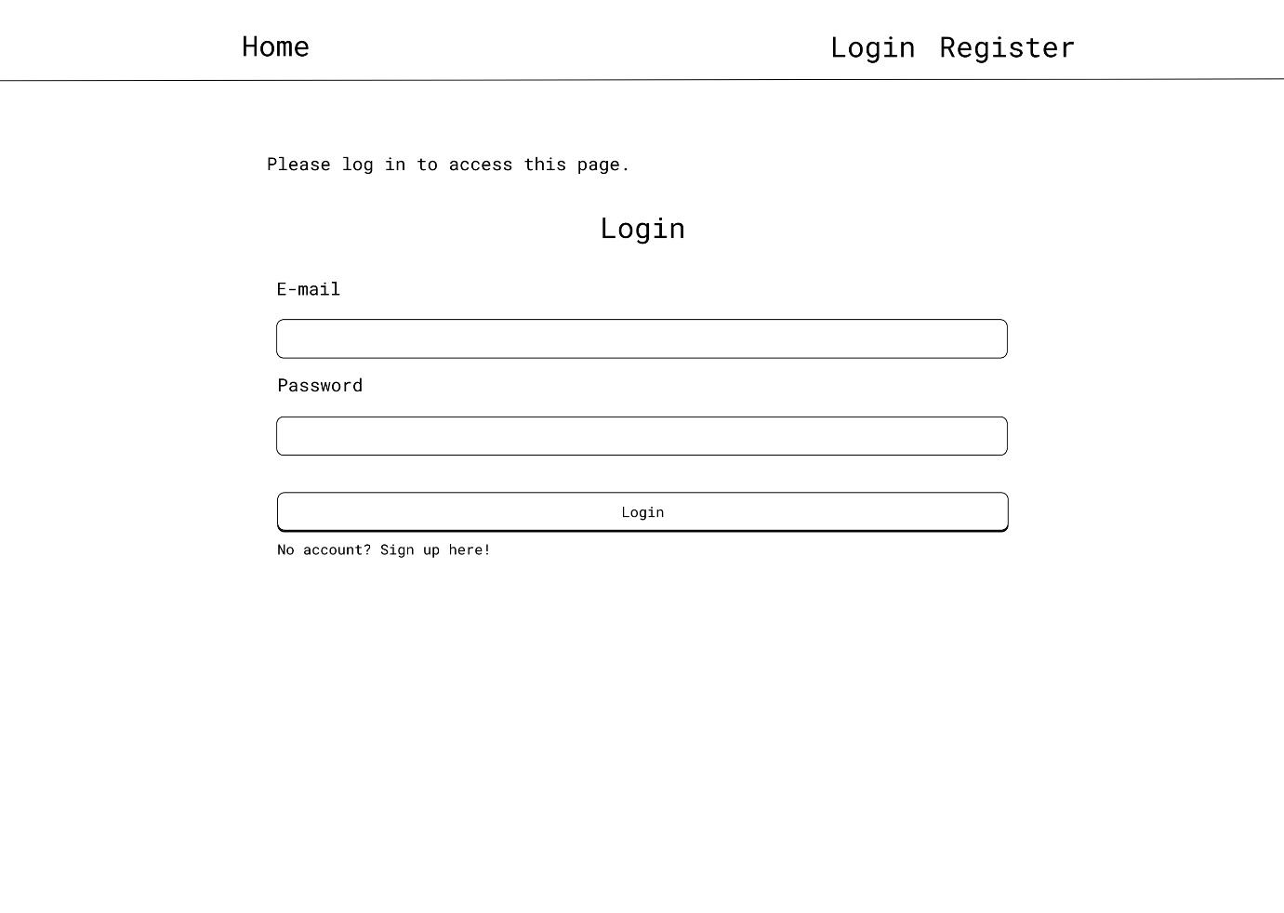

Figure 8 Home Page with Login From - any user view

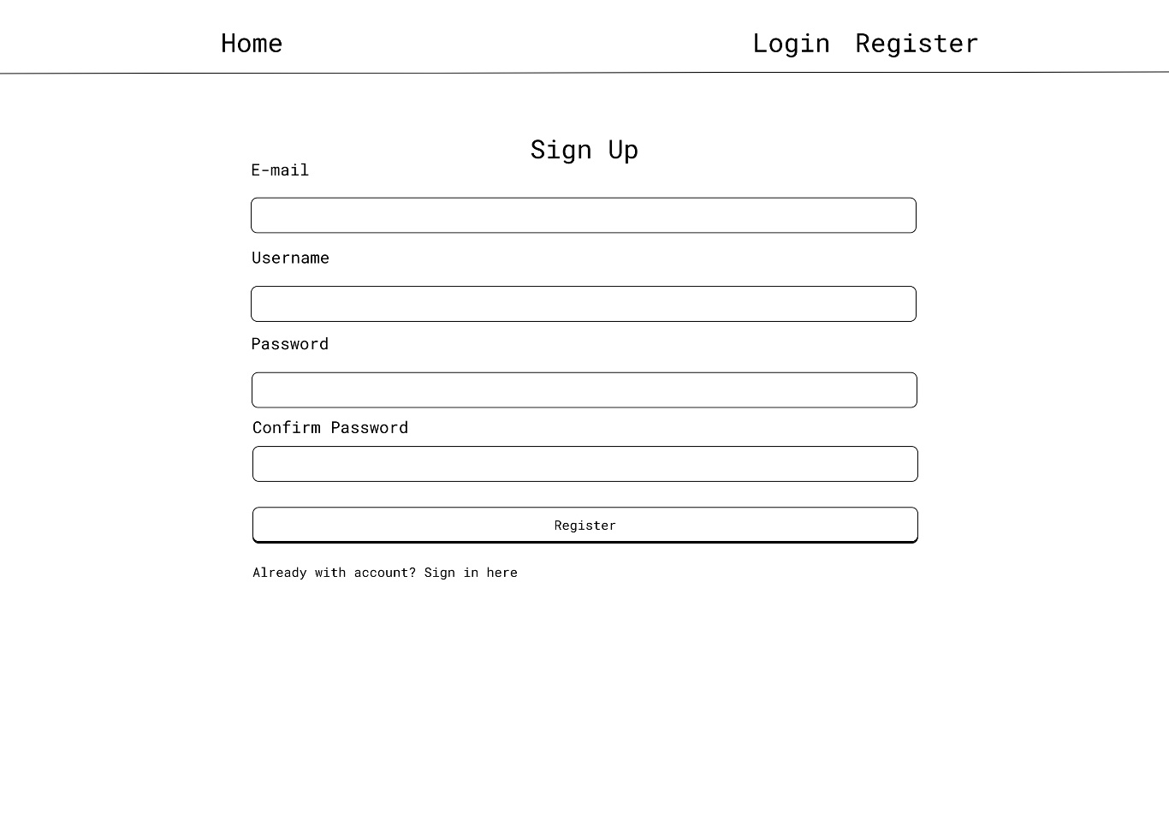

Figure 9 Register Page

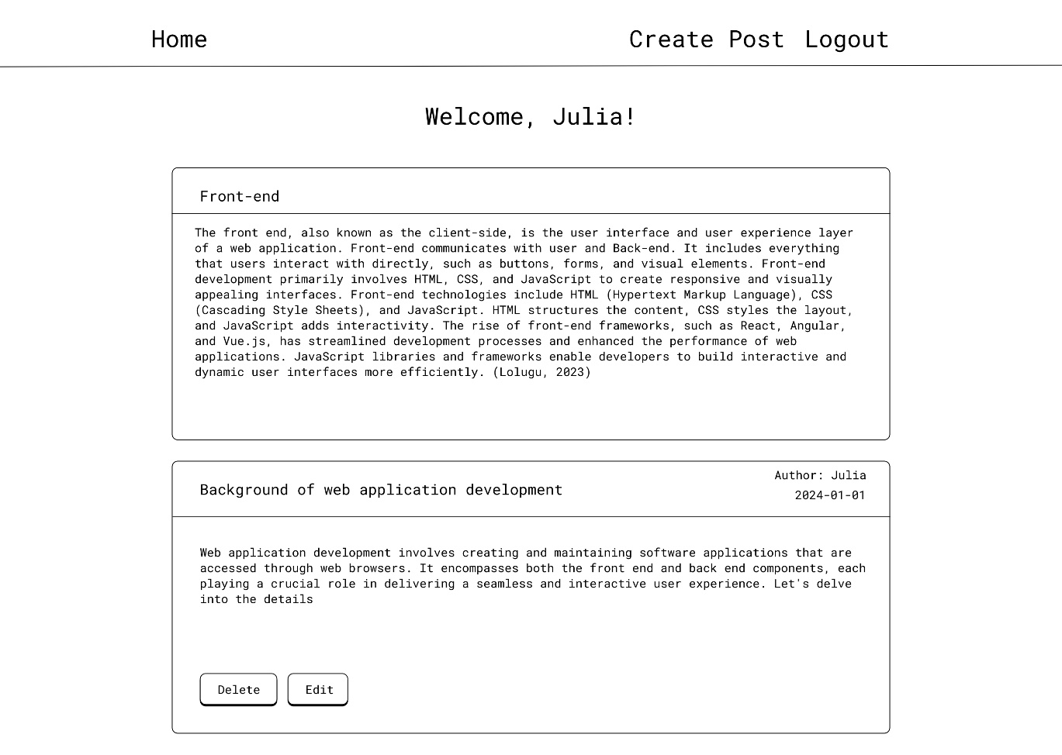

Figure 10 Home page for authorised user

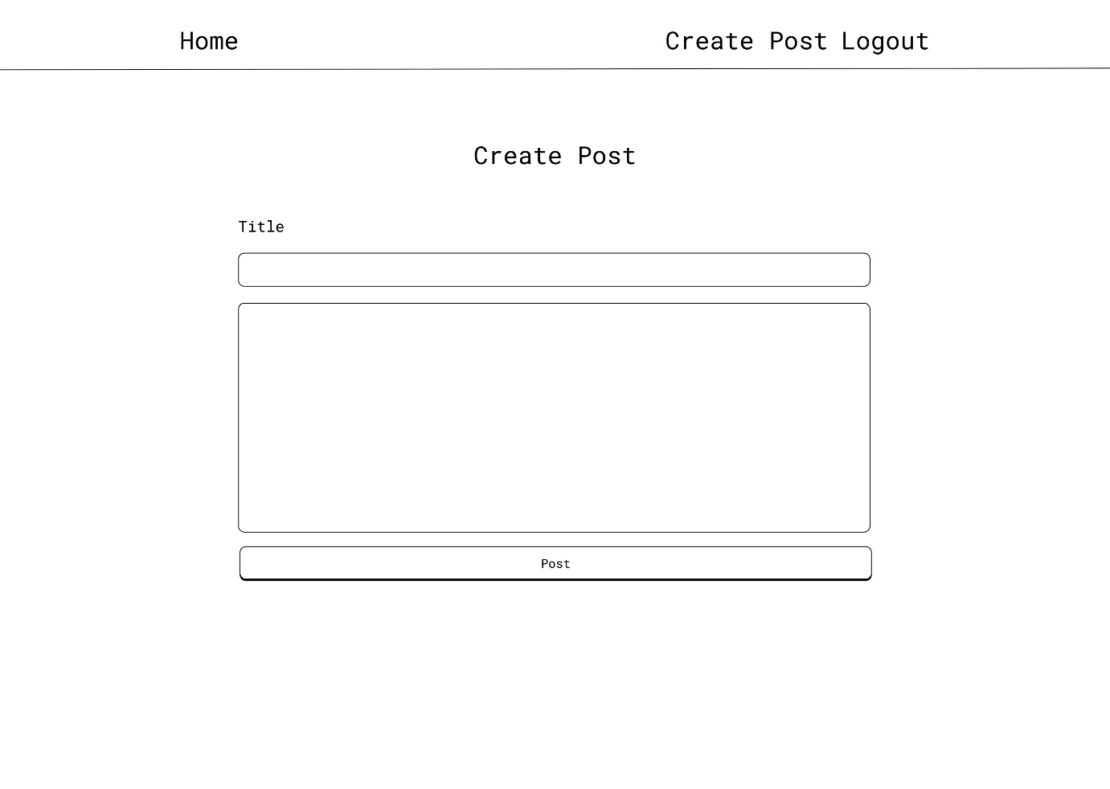

Figure 11 Create Post Page

### Universal Design Storyboard

In the development of the application, an overview for each page has been meticulously crafted, adopting a storyboard format. Each page is thoroughly outlined with its specific title, URL, actionable items, and the potential outcomes associated with those actions. Furthermore, the user has conscientiously emphasized the potential actors or users connected to each page, distinguishing among administrators, authenticated users, and non-authenticated users. This method not only facilitates a comprehensive understanding of the application's structure but also serves as a preventive measure against plagiarism. By infusing unique content and a personalized touch into the overview, the user has ensured an original and distinct representation of the application's functionality.

### Landing Page / Home Page

|  |  |
| --- | --- |
| Title | Home |
| Actor(s) | Non - authenticated users |
| Actions | 1. Login to an existing account 2. Register a new account |
| Outcome | 1. User redirected to login page 2. User redirected to register page |

### Register Page

|  |  |
| --- | --- |
| Title | Register |
| Actor(s) | Non - authenticated users |
| Actions | User initiates account registration by providing relevant information:   1. Username 2. Email 3. Password 4. Confirm Passwort |
| Outcome | Success:   1. Username is unique. 2. Email is unique. 3. The password matches. 4. Upon clicking the “Login” button, the user gains access to the application.   Failure:   1. Incorrect username message is displayed. 2. Incorrect Email message is displayed. 3. Incorrect Password message is displayed. |

### Login Page

|  |  |
| --- | --- |
| Title | Register |
| Actor(s) | Authenticated users |
| Actions | User initiates account registration by providing relevant information:   1. Username 2. Email 3. Password 4. Confirm Passwort |
| Outcome | Success:   1. Username is unique. 2. Email is unique. 3. The password matches. 4. Upon clicking the “Login” button, the user gains access to the application.   Failure:   1. Incorrect username message is displayed. 2. Incorrect Email message is displayed. 3. Incorrect Password message is displayed. |

### Community/Posts Page

### Add Post Page

### Edit Post Page

### Database Design – EER Diagram

# Comprehensive analysis

This section undertakes a comprehensive analysis of two prominent web frameworks, Flask and Django, in the context of blog development. The objective is to provide a thorough examination of their capabilities, strengths, and potential limitations when employed in constructing a blog. Flask, known for its simplicity and flexibility, will be juxtaposed against Django, a high-level web framework acclaimed for its robust features and conventions.

Through a meticulous exploration of various facets such as architecture, ease of use, extensibility, and performance, this analysis aims to offer valuable insights for developers and decision-makers seeking the most suitable framework for their blog development endeavours. The following subsections delve into the comparative evaluation of Flask and Django, shedding light on their distinct attributes and suitability in the specific context of blog implementation.

## Flask

As previously highlighted, Flask stands out as a versatile tool for expeditiously assembling web applications, be it for a modest test project or a more extensive endeavour. The primary focus is directed towards the development of a CRUD (Create, Read, Update, Delete) blog. This entails the creation of a blog with the capability to generate and modify posts, peruse existing content, and manage various aspects of post-related information.

The rationale behind opting for Flask lies in its streamlined setup process and rapid deliverance of results. The selection of Flask is underpinned by its efficacy in swiftly producing a dynamic and interactive blog that canters around CRUD actions. The framework's simplicity and agility make it an ideal solution for orchestrating a seamless and engaging user experience within the context of a blog with comprehensive CRUD functionality.

### Design Philosophy

Flask's microframework design philosophy is deeply rooted in simplicity and flexibility, providing developers with essential components for web development while avoiding unnecessary constraints. This approach allows developers to choose components, libraries, and tools that best suit their project requirements. By excluding extraneous features, Flask remains lightweight and adaptable, catering to a diverse range of development scenarios.

The explicit and minimalistic nature of Flask is a standout characteristic, empowering developers with greater control over their application's structure and components. Instead of imposing a rigid project structure, Flask enables developers to organize their code in a way that aligns with their specific needs, promoting a tailored and efficient development process. Figure 12 provides a directory structure for blog application. This structure is common for Flask applications, following the Model-View-Controller (MVC) pattern, with templates for the views and separate files for authentication and data models.

Figure 12 Directory Structure of Flask Web Application

A notable feature of Flask is its decorator-based routing system. Developers can use Python decorators to succinctly define routes and specify how different parts of the application should respond to various HTTP methods. This approach enhances code readability and encourages a modular and expressive way of handling different aspects of the application logic. By leveraging decorators, developers can easily map URL patterns to corresponding functions, streamlining the routing process.

Flask's design principles prioritize simplicity and elegance, keeping the core components straightforward and uncluttered. This focus empowers developers to concentrate on their application's unique requirements. The combination of simplicity and flexibility, along with the ability to choose components, makes Flask easy to learn, extend, and customize. This makes it an attractive choice for developers seeking a balance between simplicity and versatility in web development.

### Routing and Request Handling in Flask

Flask, a lightweight and versatile web framework for Python, offers a straightforward yet powerful mechanism for defining routes within web applications. Routing, in the context of Flask, is the process of mapping specific URLs to designated functions or views in the application. This mapping establishes the connection between user requests and the corresponding code that should be executed, allowing developers to create a structured and organized architecture for their web applications.

At the core of Flask's routing system is the use of decorators. By employing the @app.route() decorator, where app represents the Flask application instance, developers can associate a particular URL pattern with a specific view function. For instance, the following code defines a route for the root URL ("/"):

Figure 13 Routing in Flask Web Application

In this example, the home() function is seamlessly connected to the root URL. When a user navigates to the root URL of the application, this function is triggered. For authenticated users, the function seamlessly proceeds to render the "home.html" template. This template is dynamically enriched with parameters, such as the current user's username and a list of posts retrieved from the database (posts).

To ensure secure access, the function is adorned with the @login_required decorator. This decorator mandates user authentication for entry. If a user lacks authentication, the system gracefully redirects them to the login page, ensuring a smooth and secure user experience.

Flask's request handling capabilities play a pivotal role in facilitating communication between web applications and their users. The *request* object in Flask provides a versatile and comprehensive interface for accessing and manipulating incoming HTTP requests, allowing developers to extract valuable information and respond accordingly within their view functions.

One fundamental aspect of Flask's request handling is its ability to access data submitted through HTML forms. When a client submits a form on a web page, the *request.form* attribute becomes a key tool for retrieving form data in the server-side code. For instance, in a user authentication scenario where a login form is submitted via a POST request, developers can use the *request.form.get()* method to access specific form fields, such as the username and password. This capability is crucial for implementing user authentication and authorization mechanisms within Flask applications.

Figure 14 Request in Flask Web Application

The primary focus in Figure 14 is on handling the POST request, which occurs when a user submits the login form.

When a POST request is received, the code extracts the user-provided email and password from the submitted form using *request.form.get("email")* and *request.form.get("password")*, respectively. Subsequently, it queries the database to find a user with the specified email using *User.query.filter_by(email=email).first()*.

The code then checks if a user with the given email exists and if the provided password matches the hashed password stored in the database. If both conditions are met, indicating a successful login attempt, the user is logged in using *login_user(user, remember=True)*. A success flash message is also displayed using Flask's flash function, and the user is redirected to the home page using *redirect(url_for("views.home"))*.

In cases where the login attempt is unsuccessful, meaning either the user does not exist or the password is incorrect, a danger-level flash message is flashed to the user, notifying them to check their email and password.

The use of the request object is pivotal in this route, facilitating the extraction of user input from the form and allowing the application to respond appropriately based on the provided information during the login process

In conclusion, Flask's routing and request handling capabilities form the backbone of web application development. By effectively mapping URLs to view functions and facilitating seamless interaction with client requests, Flask empowers developers to create dynamic and responsive web applications with ease. The framework's simplicity and flexibility make it a popular choice for building a wide range of web-based projects.

### Template Engines in Flask

In the context of web development, Flask, a microframework for Python, provides a robust foundation for building dynamic and interactive web applications. One key aspect that enhances the development process is the integration of template engines. Template engines play a crucial role in separating the presentation layer from the business logic, promoting code modularity, and improving maintainability.

Jinja2 is the default and widely adopted template engine in Flask. Its syntax is designed to be intuitive and flexible, allowing developers to seamlessly integrate dynamic content within HTML or other markup languages. One notable feature is the use of double curly braces *({{ }})* to encapsulate expressions and variables, making it easy to embed dynamic data. Additionally, control structures such as loops and conditionals are defined using curly brace percentage pairs *({% %}),* providing a clear and concise way to manage logic within templates.

Figure 15 Jinja2 - example of syntax

The power of Jinja2 lies in its rich set of features. Filters and macros are among the essential functionalities that enhance template capabilities. Filters enable the manipulation and transformation of data directly within the template, while macros facilitate the creation of reusable components, promoting modularity and code organization. Jinja2's template inheritance mechanism is another noteworthy feature, allowing developers to create a base template with common structure and extend it in child templates, reducing redundancy and promoting maintainability.

Jinja2's extensibility is a key factor that contributes to its popularity in the Flask ecosystem. Developers can create custom filters, functions, and extensions to tailor the template engine to their specific needs. This extensibility is particularly useful when integrating Flask with other technologies or when requiring specialized functionality within templates. The ability to extend Jinja2 ensures that it remains adaptable to a wide range of use cases, making it a versatile choice for web development (Grinberg, 2018).

While Jinja2 is the default template engine in Flask, the framework provides flexibility by supporting alternative engines. One notable alternative is Mako, a fast and lightweight template engine. Mako boasts a concise and expressive syntax, featuring constructs such as *<% %>* for control statements and *${ }* for variable substitution.

The choice of template engine often depends on project requirements and developer preferences. Mako, for instance, is known for its speed and is well-suited for performance-critical applications. Its extensibility allows developers to create custom filters and functions, providing a level of customization comparable to Jinja2 (Ronacher, n/d).

Another alternative is the Django template engine, which can be integrated into Flask applications. Django's template language features a different syntax, utilizing *{% %}* for control structures and *{{ }}* for variable rendering. While Django's template engine lacks some of the features of Jinja2, it may be preferred by developers familiar with the Django ecosystem.

Ultimately, the availability of multiple template engines in Flask underscores the framework's commitment to flexibility, allowing developers to choose the tool that best aligns with their project's requirements and their own development philosophy.

In conclusion, the choice of a template engine in Flask involves considering factors such as syntax, features, and extensibility. Jinja2, as the default engine, offers a robust and expressive syntax with a rich set of features, including filters, macros, and template inheritance. Its extensibility allows developers to customize and adapt the engine to their specific needs, making it a versatile and widely adopted choice.

Alternative template engines, such as Mako and the Django template engine, provide additional options for developers seeking different syntax or performance characteristics. The decision to use one over the other depends on the specific requirements of the project and the familiarity of the development team with a particular template engine.

Overall, the availability of diverse template engines in Flask exemplifies the framework's commitment to providing developers with choices and flexibility, ensuring that they can tailor their development approach to suit the unique demands of their projects.

### Database Integration

Flask-SQLAlchemy serves as a robust bridge between Flask, a lightweight web framework, and SQLAlchemy, a versatile Object-Relational Mapping (ORM) tool in Python. This integration offers developers a seamless and efficient means of interacting with relational databases, enabling them to leverage the power of Python's object-oriented programming paradigm.

At its core, Flask-SQLAlchemy provides a high-level abstraction for database operations. Developers can define their database models as Python classes, with each class representing a table in the database. This approach fosters a natural mapping between the application's data structures and the underlying database schema, simplifying the development process.

One of the primary benefits of leveraging Flask-SQLAlchemy lies in its capacity to simplify the intricacies associated with database interactions. By encapsulating database logic within Python classes, developers can channel their efforts towards the application's business logic, thus sidestepping the complexities of intricate SQL queries. This approach leads to the creation of cleaner and more maintainable code.

Furthermore, Flask-SQLAlchemy's ability to bootstrap the database within the application context enhances its usability. However, it's crucial to note that this also means the database is confined within the application context. As demonstrated in the provided Figure 16, the database is initialized and connected. This design choice ensures that the database cannot be accessed outside the application context, reinforcing a more secure and controlled environment.

Figure 16 Database in Flask

The use of SQLAlchemy as the underlying ORM library further enhances Flask-SQL Alchemy’s capabilities. SQLAlchemy supports a wide range of database backends, including popular choices like PostgreSQL, MySQL, and SQLite. This flexibility enables developers to switch between different databases with minimal code changes, promoting scalability and adaptability.

### User Authentication and Authorization in Flask

Flask-Login and Flask-WTF are two widely used extensions in the Flask web framework that facilitate user authentication and form handling, respectively.

Flask-Login is primarily designed for user authentication in Flask applications. It provides a straightforward way to manage user sessions and login functionality. With Flask-Login, developers can easily integrate user authentication features into their applications, such as handling user sessions, protecting routes that require authentication, and managing user information (Frazier, 2023).

When it comes to handling forms in Flask applications, Flask-WTF (WTForms integration for Flask) is a popular choice. Flask-WTF extends the functionality of WTForms, a form-handling library for Python, making it easier to create and manage web forms in Flask applications. It helps with form validation, CSRF protection, and rendering forms in templates.

The integration of Flask-Login and Flask-WTF allows developers to create secure and user-friendly authentication systems. Users can submit login forms, and Flask-Login takes care of validating credentials, creating user sessions, and managing the authentication state. Flask-WTF, on the other hand, ensures that forms are generated with the necessary security measures, such as CSRF tokens, to protect against cross-site request forgery attacks.

Implementing user roles and permissions is crucial for building robust web applications with varying levels of access. Flask-Login provides a foundation for user authentication, but for handling roles and permissions, developers often need to implement additional logic. This may involve associating roles with user accounts and checking for specific permissions when processing requests.

By leveraging Flask-WTF for form handling, developers can create user registration forms and profile management forms that capture additional information, including user roles and permissions. Custom validation logic within these forms can help enforce business rules related to roles and permissions, ensuring that users are granted appropriate access based on their roles (GeeksForGeeks, N/D).

In conclusion, Flask-Login and Flask-WTF complement each other in building a secure and user-friendly authentication system in Flask applications. While Flask-Login focuses on managing user sessions and authentication, Flask-WTF facilitates the creation and validation of forms. Combining these extensions provides a solid foundation for implementing user roles and permissions, allowing developers to create applications with varying levels of access control.

### Testing in Flask

Unit testing is a crucial aspect of software development to ensure the reliability and functionality of individual components. Flask, a lightweight web framework for Python, provides robust support for unit testing through its built-in testing tools and compatibility with popular testing frameworks. When conducting unit testing in Flask, developers can employ various tools and frameworks such as *unittest* and *pytest* to create effective test suites.

Flask integrates seamlessly with Python's built-in unittest module, offering a straightforward approach to organizing and executing unit tests. Developers can create test cases by subclassing *unittest.TestCase* and defining individual test methods within these classes. These methods can then be used to assess the behaviour of specific components or functionalities of a Flask application.

On the other hand, many developers prefer to use pytest for its simplicity, flexibility, and rich feature set. Leveraging *pytest* for unit testing in Flask not only streamlines the testing process but also enhances the readability and maintainability of test code.

One of the key advantages of *pytest* is its ability to provide concise and expressive test code. By utilizing plain Python functions instead of the more verbose class-based approach of *unittest*, developers can write tests with minimal boilerplate, making the code easier to understand and maintain. This simplicity is particularly advantageous when testing Flask applications, as it allows developers to focus more on the actual testing logic rather than the test infrastructure.

Additionally, *pytest* offers powerful features such as fixtures, parameterized testing, and test discovery, which further contribute to its appeal. Fixtures in *pytest* enable the setup and teardown of test environments, allowing developers to define reusable components for common setup operations. Parameterized testing allows for the efficient testing of multiple input-output combinations by specifying parameters for test functions. Test discovery, another useful feature, automatically identifies and runs test modules and functions, reducing the need for manual configuration.

To illustrate pytest in action within a Flask application, consider the following example:

By employing *pytest* alongside Flask, developers can create comprehensive and effective test suites that validate the functionality of their applications with ease. The combination of Flask's simplicity and flexibility with *pytest* powerful testing capabilities enables developers to ensure the reliability and robustness of their Flask-based projects.

In terms of best practices, a systematic approach to unit testing in Flask involves testing each component in isolation to ensure that it functions as intended. This practice promotes modularity and simplifies debugging. Developers should focus on testing not only the positive scenarios but also edge cases and potential failure points to enhance the overall robustness of the application.

Additionally, creating a comprehensive suite of unit tests enables developers to catch and address issues early in the development process, reducing the likelihood of bugs making their way into the production environment. Continuous integration (CI) systems can be employed to automatically run unit tests whenever changes are made to the codebase, ensuring ongoing validation of the application's functionality (Grinberg, 2018).

In conclusion, Flask's support for unit testing, combined with the flexibility of tools like *unittest* and *pytest*, allows developers to create effective test suites for their applications. Adhering to best practices, such as testing in isolation and covering a range of scenarios, contributes to the overall reliability and maintainability of Flask-based projects.

### Community and Ecosystem

The Flask web framework, known for its simplicity and flexibility, has cultivated a vibrant community of developers and enthusiasts since its inception. Comparing the size and activity of communities surrounding Flask involves examining factors such as user engagement, support forums, and contribution metrics. Additionally, the availability of third-party packages and extensions further enriches the Flask ecosystem, enhancing its functionality and versatility.

In terms of community size, Flask boasts a substantial following with a diverse range of users worldwide. Its community spans across various online platforms, including official documentation forums, GitHub repositories, Stack Overflow threads, and dedicated discussion forums. These platforms serve as hubs for users to seek assistance, share knowledge, and collaborate on projects. Moreover, Flask's active presence on social media platforms facilitates community engagement and outreach, fostering a dynamic and inclusive environment for developers of all skill levels.

The activity within the Flask community is reflected in the frequency of discussions, contributions, and updates across different channels. GitHub, a popular platform for hosting open-source projects, showcases the ongoing development and maintenance of Flask and its associated libraries. The repository for Flask itself receives regular updates, indicating active development and community involvement. Additionally, forums and discussion boards dedicated to Flask witness continuous interactions, where users exchange ideas, troubleshoot issues, and propose enhancements.

The availability of third-party packages and extensions further enhances Flask's capabilities and accelerates development workflows. The Python Package Index (PyPI) hosts a plethora of Flask extensions and utilities, ranging from authentication modules to database integrations and API frameworks. These packages cater to various requirements and use cases, empowering Flask developers to extend their applications with minimal effort. Furthermore, the Flask community actively contributes to the development and maintenance of these packages, ensuring compatibility with the latest versions of Flask and adherence to best practices (Ronacher, 2024).

### Scalability and Performance

Flask, a lightweight and flexible web framework written in Python, is renowned for its simplicity and extensibility, making it a popular choice for building web applications. Its scalability and performance aspects are crucial considerations for developers aiming to deploy applications efficiently. Flask's scalability largely depends on the underlying WSGI server and the architecture of the application itself.

One of the key factors influencing Flask's scalability is its ability to integrate seamlessly with various WSGI servers such as Gunicorn, uWSGI, and mod_wsgi. These servers handle concurrent requests efficiently, allowing Flask applications to scale horizontally by distributing the workload across multiple processes or threads. For instance, Gunicorn's asynchronous worker model enables concurrent request handling, thereby enhancing the overall scalability of Flask applications (Chesneau, 2023).

Moreover, Flask's lightweight design and minimalistic approach contribute to its performance optimization. By adhering to the principles of simplicity and minimalism, Flask minimizes overhead and unnecessary abstractions, resulting in faster request processing times. Additionally, Flask's modular architecture enables developers to selectively incorporate extensions and middleware to further optimize performance based on specific requirements.

Furthermore, numerous case studies highlight Flask's performance in real-world applications. For instance, Pinterest, a popular image sharing platform, utilizes Flask for various microservices, showcasing its scalability and reliability in handling millions of requests daily. Similarly, Reddit, a widely used social news aggregation platform, leverages Flask for certain components of its architecture, underscoring Flask's suitability for high-traffic websites.

In conclusion, Flask's scalability and performance aspects are crucial considerations for developers aiming to build efficient web applications. Its seamless integration with WSGI servers, lightweight design, and modular architecture contribute to its scalability and performance optimization. Real-world benchmarks and examples validate Flask's capabilities in handling concurrent requests and powering high-traffic websites, making it a preferred choice for building robust and efficient web applications (Ronacher, 2024).

## Django

Django, like Flask, is a robust framework for rapid web application development. Choosing Django for building a CRUD-based blog is driven by its strong architecture, built-in features, and ORM system. With Django's convention over configuration and batteries-included approach, creating a dynamic blog with full CRUD functionality becomes efficient.

The MVT architecture ensures a clear separation of concerns, simplifying the handling of post-related information. Django's integrated admin interface, security features, and extensibility contribute to a solid foundation for developing a feature-rich and secure blog. The framework's adherence to the DRY principle ensures maintainable code and scalability.

In summary, Django provides a comprehensive solution for developing a CRUD-based blog with its organized structure, built-in tools, and active community support. Whether for beginners or experienced developers, Django's versatility and scalability make it an ideal choice for delivering a dynamic and engaging user experience in the context of a blog application.

### Design Philosophy

Django, in contrast to microframeworks like Flask, embraces a full-featured framework design philosophy, embodying a "batteries-included" approach. This means Django comes equipped with a rich set of built-in features that cover a wide range of common web development tasks. This comprehensive nature of Django is particularly advantageous for developers who prefer a more opinionated framework that streamlines the development process by providing pre-built solutions for various functionalities.

A defining characteristic of Django is its adherence to the convention over configuration principle. This design choice enforces a specific project structure and naming conventions, which contributes to a standardized and easily navigable codebase. By prescribing conventions, Django minimizes the need for explicit configuration, allowing developers to focus more on application logic and less on setup and boilerplate code. This convention-driven approach also facilitates collaboration among developers, as it establishes a shared understanding of project organization.

Django's architectural pattern follows the MTV (Model-Template-View) structure (Figure ADD NUMBER), a variation of the more traditional MVC (Model-View-Controller) pattern. In this paradigm, the model represents the data structure and handles database interactions, the template manages the presentation layer, and the view is responsible for handling business logic and coordinating the interaction between the model and the template. This separation of concerns enhances code modularity and maintainability, making it easier for developers to understand, modify, and extend different components of the application independently.

Figure 17 Directory Structure of Django Web Application

The MTV pattern in Django allows for a clear separation between the different aspects of web development, promoting a modular and scalable approach. Developers can focus on defining models to represent data, crafting templates for presentation, and implementing views to handle the application's business logic. This architectural structure contributes to the maintainability and scalability of Django projects, making it a suitable choice for complex and feature-rich web applications. The combination of a comprehensive feature set, convention over configuration, and the MTV architectural pattern positions Django as a powerful and efficient framework for building a wide variety of web applications.

### Routing and Request Handling in Django

Routing in Django plays a crucial role in directing incoming requests to the appropriate views and handling URLs within a web application. Django employs a flexible and powerful URL routing system that allows developers to design clean and maintainable URL structures.

Django utilizes a file called *urls.py* within each app to define the URL patterns associated with that specific application. These patterns determine how URLs are mapped to views, which are responsible for processing requests and returning appropriate responses. Figure 16 is an example to illustrate the essence of Django routing

Figure 18 Routing in Django Web Application

In this example, the code defines two URL patterns *('/' and '/register/'),* mapping to the home and register view functions, respectively. The use of the name parameter allows you to refer to these patterns elsewhere in your Django project using the provided names ("home" and "register"). However, you might want to reconsider having both *'/home/' and '/'* mapped to the same home view unless there's a specific reason for it.

To incorporate these URL patterns into the main project, the urls.py file at the project level is utilized. This file typically includes the URLs of all the individual apps that make up the project. An example might look like on Figure 17.

Figure 19 Registered routing in Django Web Application

Here, the include function is employed to reference the URL patterns defined in the urls.py file of the *'blog'* app. When a user accesses a URL starting with *'blog/'*, the control is passed to the *blog.urls* file for further processing.

Django is a powerful web framework for building dynamic web applications using the Python programming language. At its core, Django follows the Model-View-Controller (MVC) architectural pattern, with a slight variation known as Model-View-Template (MVT). One crucial aspect of Django development is handling HTTP requests, which play a pivotal role in the communication between clients and the server. In this context, the request object is a fundamental component that encapsulates information about the current HTTP request.

When a user interacts with a Django-powered website by clicking links, submitting forms, or accessing URLs, the Django application receives an HTTP request. The request object provides access to various details associated with this incoming request. These details include parameters, headers, cookies, and the requested URL. By utilizing the request object, developers can extract information about the client's intentions and customize their application's behaviour accordingly.

The request object is automatically created by Django and is accessible within views, which are responsible for processing user requests and generating appropriate responses. As part of the Django request-handling process, the framework routes the incoming request to the corresponding view function based on the URL patterns defined in the application.

Developers can access various attributes of the request object to retrieve valuable information. For instance, the *request.GET* attribute allows access to query parameters from the URL, while *request.POST* contains data submitted through POST requests, typically associated with form submissions. Additionally, request.method indicates the HTTP method used (GET, POST, etc.), and request.path represents the requested URL path.

Understanding and effectively utilizing the request object is crucial for building dynamic and responsive web applications with Django. This object empowers developers to capture user input, respond to specific HTTP methods, and customize application behaviour based on the contextual information provided by the client's request. In summary, the request object in Django serves as a gateway to handling and responding to HTTP requests, making it an integral part of the framework's functionality and contributing to the development of robust and interactive web applications.

Django views are essential components responsible for processing user requests. In the provided code snippet, Figure NUMBER implemented a Django view for user registration.

Figure 20 Request in Django Web Application

The register view employs the request object to distinguish between HTTP methods (GET and POST). When the method is POST, the request.POST data is used to instantiate a RegistrationForm, and if the form is valid, a new user is registered, and the user is automatically logged in. The redirect function utilizes the request object to redirect the user to the home page upon successful registration.

In conclusion, the routing and request handling mechanisms in Django play a pivotal role in defining how web applications manage incoming requests and direct them to the appropriate views for processing. The URL patterns defined in the project's URLs configuration act as a roadmap, guiding the application to the relevant views based on the requested URL. With the use of regular expressions and named groups, Django provides a flexible and powerful way to capture dynamic components of URLs. Additionally, the request handling process involves middleware, which allows for pre-processing and post-processing of requests, contributing to a modular and extensible architecture. The clear separation of concerns in Django's routing and request handling ensures a clean and maintainable codebase, making it easier for developers to manage and scale their web applications. Understanding these concepts is essential for Django developers to create well-organized and efficient web applications.

### Template Engines in Django

Template engines play a crucial role in web development, facilitating the separation of concerns between the backend logic and frontend presentation in a web application. In the context of Django, a popular Python web framework, the template engine serves as a powerful tool for creating dynamic and interactive web pages.

Django employs its own template engine, aptly named the Django Template Language (DTL). DTL is designed to be concise, expressive, and user-friendly, allowing developers to embed dynamic content seamlessly within HTML markup. One key advantage of DTL is its template inheritance feature, which enables the creation of a consistent layout across multiple pages by defining a base template and extending it for specific views. This promotes the DRY (Don't Repeat Yourself) principle, streamlining development and enhancing the overall structure of web applications.

Furthermore, Django's template engine supports the use of template tags and filters, providing a wide range of tools for manipulating data and rendering dynamic content. Template tags enable the inclusion of control structures, such as loops and conditionals, directly within the HTML templates, enhancing the flexibility of frontend development. Additionally, filters empower developers to transform and format data on the fly, ensuring that the presentation layer meets the desired aesthetic and functional requirements.

The extensibility of Django's template engine is another noteworthy feature, allowing developers to create custom template tags and filters tailored to the specific needs of their applications. This extensibility enhances the adaptability of the framework, making it suitable for a diverse range of web development projects.

While Django's built-in template engine, the Django Template Language (DTL), offers robust features and capabilities, the framework also provides flexibility for developers to integrate alternative template engines based on specific project requirements. Two notable alternatives include Jinja2 and Mako, each offering unique advantages and characteristics.

Jinja2, a popular template engine in the Python ecosystem, has gained recognition for its concise syntax and powerful template inheritance features. Django allows developers to seamlessly integrate Jinja2 into their projects, offering a different approach to template rendering. Jinja2's syntax is similar to Python, making it more familiar for developers already accustomed to the language. This alternative template engine brings additional capabilities such as macro definitions, making it a compelling choice for those seeking a lightweight and expressive solution.

Mako is another alternative template engine that Django supports. Mako distinguishes itself with a focus on speed and efficiency. It employs a simple syntax that encourages developers to write templates that are easy to understand and maintain. Mako supports inline expressions and provides a variety of features for dynamic content rendering. By allowing developers to embed Python code directly within templates, Mako provides a powerful and flexible solution for those who prioritize performance and simplicity (Bayer, n/d).

Integrating alternative template engines in Django is facilitated by the framework's modularity and adherence to the WSGI standard. This flexibility allows developers to choose the template engine that best aligns with the project's goals and development preferences. While DTL remains the default and widely used engine in Django, the ability to seamlessly incorporate alternatives showcases the framework's commitment to accommodating diverse developer needs and promoting a thriving ecosystem.

In conclusion, Django's template engine, the Django Template Language (DTL), plays a vital role in web development by facilitating the separation of concerns and providing a powerful tool for creating dynamic web pages. The template inheritance feature, support for tags and filters, and extensibility contribute to a streamlined and flexible development process, aligning with the DRY principle and enhancing the overall structure of web applications.

While DTL remains the default and widely used engine in Django, the framework's flexibility allows developers to integrate alternative template engines such as Jinja2 and Mako. These alternatives bring unique advantages, such as concise syntax, powerful template inheritance, and a focus on speed and efficiency, catering to different developer preferences and project requirements.

The ability to seamlessly incorporate alternative template engines showcases Django's commitment to accommodating diverse needs and promoting a thriving ecosystem. Whether developers opt for the familiarity of DTL or explore alternatives, Django continues to stand as a versatile and adaptable framework in the realm of web development. The choice of a template engine becomes a strategic decision, allowing developers to balance expressiveness, performance, and ease of use based on the specific goals of their projects.

### Database Integration

Django's Object-Relational Mapping (ORM) system serves as a crucial component in simplifying database interactions within Django applications. It is built on the principle of abstraction, providing developers with a high-level, Pythonic interface to interact with relational databases without the need for writing raw SQL queries. The ORM facilitates seamless communication between Python objects and database tables, enabling developers to focus on application logic rather than dealing with intricate database operations.

Model Definition:

At the core of Django's ORM is the concept of models. Models in Django are Python classes that represent the structure of database tables. Each attribute of the class corresponds to a field in the table, defining the type of data it can hold. The ORM supports various field types, allowing developers to create comprehensive data models. This model-centric approach enhances code readability and maintainability, as the data schema is defined in a concise and expressive manner directly within the Python code.

The Django documentation on models provides in-depth information on how to define models, including the various field types and options available, ensuring that developers can create robust and well-organized data structures.

Figure 21 Models in Django

Migrations:

Django's migration system complements the model definition process, providing a structured way to manage database schema changes over time. Migrations are represented as Python files that capture the alterations made to models, such as adding or modifying fields, creating tables, or establishing relationships. The migration files serve as a version-controlled history of the database schema, allowing developers to apply these changes consistently across development, testing, and production environments. The use of Django management commands, such as *makemigrations* and *migrate*, ensures a smooth and automated process for applying migrations and maintaining database consistency.

Querying:

The querying capabilities of Django's ORM are robust and expressive, providing developers with a QuerySet API that closely mirrors SQL syntax. QuerySets allow for complex database queries, including filtering, sorting, and aggregating data, using a high-level, Pythonic syntax. This abstraction promotes code readability and reduces the likelihood of SQL injection vulnerabilities. Additionally, Django's ORM supports lazy loading, fetching data from the database only when needed, optimizing performance by minimizing unnecessary database queries.

Moreover, the ORM provides a consistent and database-agnostic interface, allowing developers to switch between different database backends seamlessly. This flexibility ensures that Django applications can adapt to varying database requirements without significant code modifications.

In conclusion, Django's ORM simplifies database interactions by providing a powerful yet easy-to-use abstraction layer. Through model definition, migrations, and querying, the ORM streamlines the development process, promoting code clarity, maintainability, and adaptability to different database systems (Django, N/D).

### User Authentication and Authorization in Django

Django, a powerful web framework for building robust and scalable applications, incorporates a comprehensive built-in authentication system that streamlines user management processes. The framework offers functionalities for user registration, login, and password reset, providing a secure foundation for user authentication.

User registration in Django is facilitated through the use of built-in forms and views, allowing developers to easily integrate registration features into their applications. Django's authentication system manages user credentials securely, employing industry-standard hashing algorithms to store passwords, ensuring confidentiality.

The login process is simplified with Django's authentication middleware, which handles user sessions and secure cookie-based authentication. This middleware seamlessly integrates with Django's user model, allowing developers to access user information and implement role-based access control. The framework's flexibility is evident in its support for custom user models, enabling developers to extend and tailor user attributes to meet specific application requirements.

Django's password reset functionality enhances user experience by providing a straightforward mechanism for users to recover lost passwords. This feature includes email notifications and secure token-based verification to ensure the privacy and security of the reset process.

In terms of user permissions, Django employs a robust system that integrates seamlessly with its authentication framework. The framework follows a model-view-template (MVT) architecture, allowing developers to implement permissions at the model level, controlling access to specific database records. Additionally, Django's built-in decorators and mixins simplify the process of enforcing permissions at the view level, ensuring that users only have access to the appropriate resources based on their roles.

Furthermore, Django introduces the concept of groups, enabling developers to assign multiple permissions to a set of users, streamlining the management of access control for various sections of an application. This hierarchical approach to permissions enhances the granularity of access control and supports the creation of complex authorization structures (Django, N/D).

In conclusion, Django's built-in authentication system provides a comprehensive suite of features for user registration, login, and password reset. The framework's user permissions mechanism, coupled with support for custom user models and groups, empowers developers to implement robust and flexible access control within their applications. The seamless integration of these features contributes to Django's reputation as a reliable and secure choice for web development projects.

### Testing in Django

In the realm of web development, particularly with Django, unit testing plays a pivotal role in ensuring the reliability and functionality of software applications. Django, a high-level Python web framework, provides a robust testing framework that facilitates the creation and execution of unit tests. This framework empowers developers to systematically validate individual components of their codebase, contributing to the overall stability and maintainability of the application.

Django's testing tools include a dedicated module called *django.test*, which houses essential classes and functions for constructing and running tests. Developers can create test cases by subclassing the *django.test.TestCase* class, which not only integrates the Django testing framework but also provides a test database for isolating test data from the production database. This segregation helps maintain data integrity during the testing process, preventing unintended consequences on the actual application data.

To facilitate the execution of tests, Django supports the use of the manage.py utility, allowing developers to run tests with a simple command. This integration streamlines the testing workflow, making it convenient for developers to regularly assess the functionality of their codebase. Additionally, Django provides fixtures, which are pre-defined sets of data that can be loaded into the test database, aiding in the creation of a controlled environment for testing.

When it comes to writing effective tests, adhering to best practices is paramount. Developers should adopt a systematic approach, focusing on testing individual components in isolation to ensure that each unit functions as expected. Test cases should cover various scenarios, including edge cases and potential error conditions, to enhance the robustness of the application.

Furthermore, maintaining a comprehensive suite of unit tests is essential for continuous integration and deployment pipelines. Automated testing tools and frameworks, such as Jenkins, Travis CI, or GitHub Actions, can be integrated into the development workflow to automatically execute tests upon code changes. This practice ensures that new features or modifications do not introduce regressions and helps maintain the overall health of the codebase.

In conclusion, Django's support for unit testing, accompanied by its testing tools and frameworks, empowers developers to create a reliable and robust web application. By adhering to best practices and incorporating automated testing into the development workflow, Django developers can confidently deliver high-quality software that meets the demands of modern web development.

### Community and Ecosystem

Django, a high-level Python web framework, has garnered a large and active community of developers and enthusiasts due to its comprehensive feature set and robust architecture. Analysing the size and activity of the communities around Django involves examining various metrics, such as user engagement, community forums, and contribution statistics. Additionally, the availability of third-party packages and extensions greatly contributes to Django's ecosystem, enhancing its functionality and extensibility.

Django's community is notable for its size and diversity, encompassing developers from around the globe with varying levels of expertise and backgrounds. Official Django documentation forums, mailing lists, and online discussion platforms serve as hubs for users to seek guidance, share insights, and collaborate on projects. Moreover, Django's active presence on social media platforms fosters community engagement and facilitates knowledge sharing among members.

The activity within the Django community is evidenced by the numerous contributions and interactions across different channels. The official Django GitHub repository, where the framework's source code is hosted, receives regular updates and contributions from developers worldwide. Additionally, forums like the Django Users Google Group and Stack Overflow's Django tag witness continuous discussions on various topics, including best practices, troubleshooting, and project showcases. These platforms provide valuable resources for both beginners and experienced developers, contributing to the vibrancy of the Django community.

The availability of third-party packages and extensions significantly enhances Django's capabilities and accelerates development workflows. The Python Package Index (PyPI) hosts a vast collection of Django packages, covering a wide range of functionalities such as authentication, database integration, content management, and more. These packages, commonly referred to as "Django apps," enable developers to leverage pre-built solutions and focus on application logic rather than reinventing the wheel. Moreover, the Django community actively maintains and updates these packages, ensuring compatibility with the latest versions of Django and adherence to coding standards (Django, N/D).

### Scalability and Performance

Django, a high-level Python web framework, is renowned for its "batteries-included" approach, robustness, and scalability. Understanding its scalability and performance aspects is essential for developers seeking to deploy large-scale web applications efficiently. Django's scalability is influenced by various factors, including its architecture, ORM (Object-Relational Mapping) efficiency, and the ability to leverage caching mechanisms.

At the core of Django's scalability is its architectural design, which follows the Model-View-Controller (MVC) pattern, facilitating the separation of concerns and modular development. This architecture allows developers to scale different components of their applications independently, enabling horizontal scaling by distributing the workload across multiple servers or instances. Additionally, Django's support for asynchronous views through channels further enhances its scalability, enabling efficient handling of concurrent requests.

Furthermore, Django's ORM plays a crucial role in optimizing database interactions and improving performance. By providing an abstraction layer over database operations, Django's ORM allows developers to write Pythonic code while automatically generating efficient SQL queries. This abstraction minimizes the risk of performance bottlenecks associated with complex database operations, thus contributing to the scalability of Django applications.

In terms of performance optimization, Django offers built-in caching mechanisms that can significantly improve response times and reduce server load. By caching database queries, rendered templates, and other computationally expensive operations, Django reduces the need for repetitive computations, thereby enhancing application performance, especially under high traffic conditions.

Moreover, numerous high-traffic websites and web applications rely on Django as their backend framework, demonstrating its scalability and performance in real-world scenarios. For example, Instagram, a popular social media platform, successfully handles millions of concurrent users using Django, underscoring its ability to scale effectively. Similarly, Disqus, a widely used commenting platform, relies on Django to handle millions of requests daily, highlighting its suitability for large-scale web applications.

In conclusion, Django's scalability and performance aspects make it a preferred choice for building scalable and high-performance web applications. Its architectural design, ORM efficiency, support for asynchronous views, and built-in caching mechanisms contribute to its scalability and performance optimization. Real-world benchmarks and examples validate Django's capabilities in handling high traffic and powering mission-critical web applications, cementing its position as a leading web framework (Adrian Holovaty, Jacob Kaplan-Moss, 2009).

### Build-in features

Django, a high-level Python web framework, comes equipped with a plethora of built-in features that streamline the development of web applications. One such feature is its robust admin interface, Figure NUMBER.

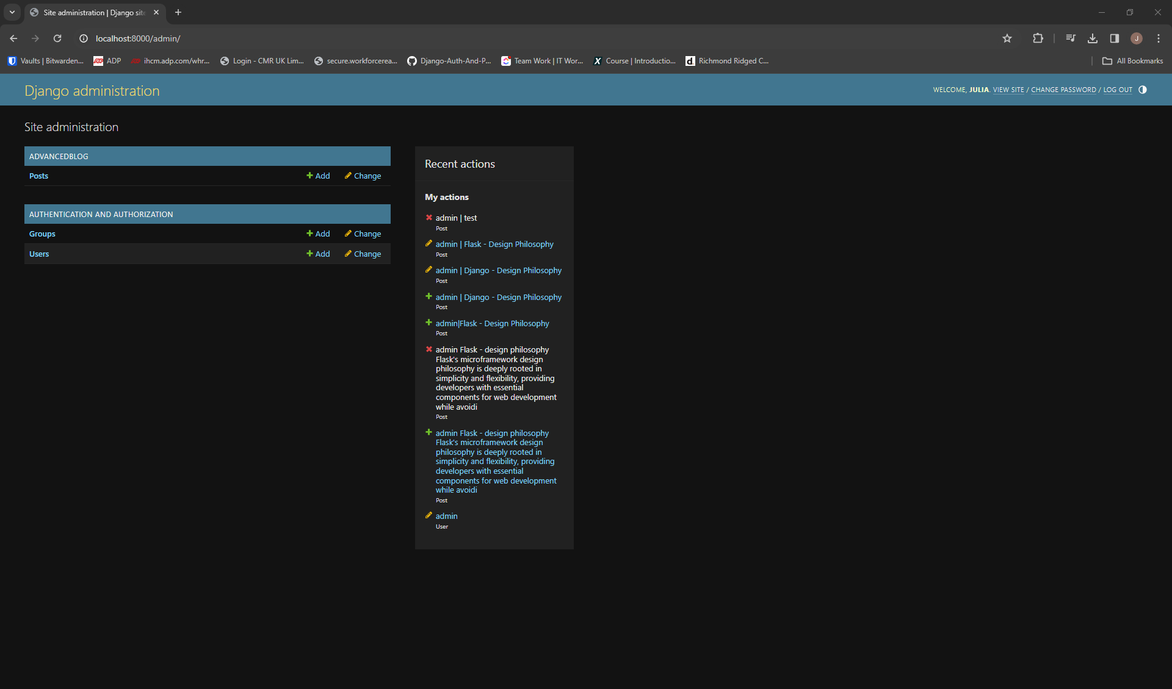

Figure 22 Admin Interface

The admin interface is an out-of-the-box feature that provides developers with a powerful tool for managing site content. With just a few lines of code, developers can create a fully functional admin interface that allows for easy manipulation of data models. This interface automatically generates forms for creating, editing, and deleting model instances, saving developers significant time and effort.

Furthermore, the admin interface in Django is highly customizable, allowing developers to tailor it to the specific needs of their application. They can define custom admin views, add filters and search functionality, and even integrate third-party libraries to enhance its capabilities. This flexibility enables developers to create admin interfaces that are intuitive and efficient, providing a seamless experience for content management.

Another key built-in feature of Django is its comprehensive form handling capabilities. Django provides a powerful form library that simplifies the process of validating and processing user input. Developers can define forms using Python classes, Figure NUMBER

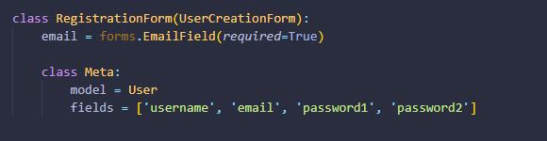

Figure 23 Class Form Declaration

leveraging built-in field types and validation rules to ensure data integrity, Figure NUMBER.

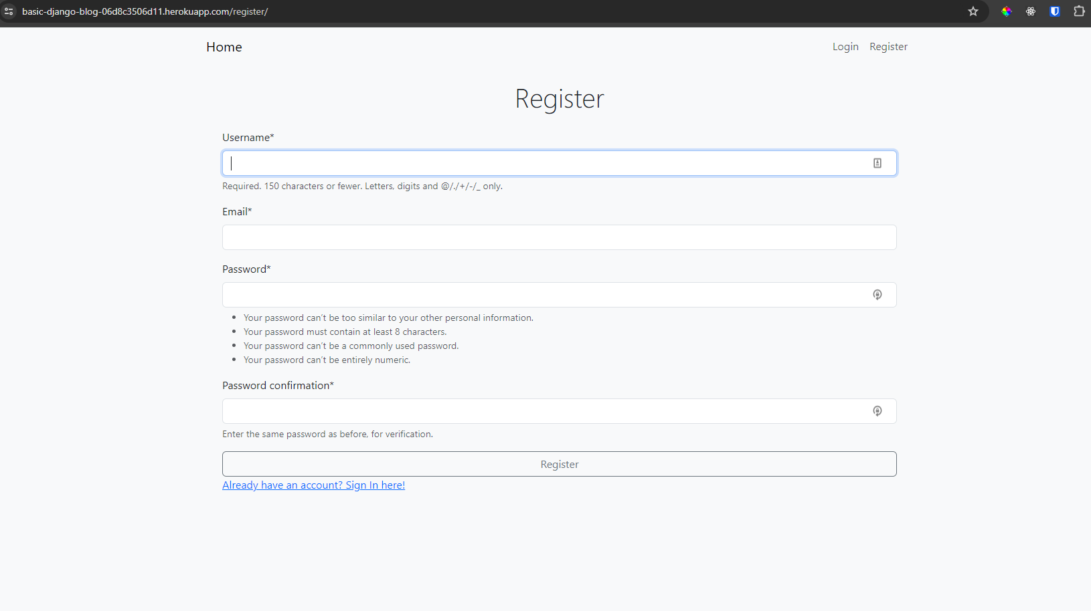

Figure 24 Register form created by Django feature

Additionally, Django's form handling features include built-in protection against common security threats such as cross-site request forgery (CSRF), Figure NUMBER, making it easier for developers to build secure web applications.

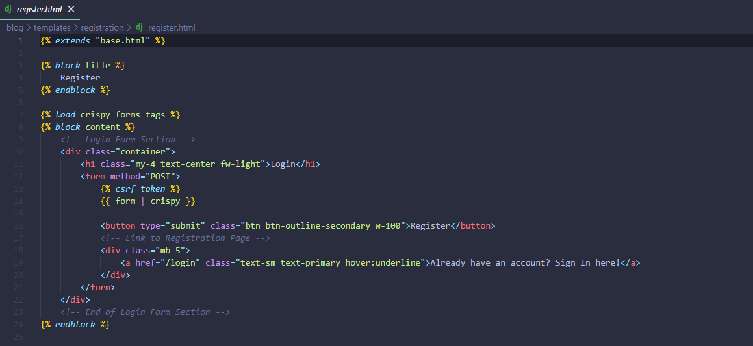

Figure 25 Crispy forms with CSRF

Moreover, Django's form handling features seamlessly integrate with its model layer, allowing developers to create forms that directly interact with database models. This tight integration simplifies the process of building forms for data entry, update, and deletion, eliminating the need for redundant code and reducing the risk of errors. Additionally, Django's form handling features support internationalization and localization, making it easy to build applications that cater to users from diverse linguistic backgrounds.

In conclusion, Django's built-in features, including its admin interface and form handling capabilities, significantly simplify the process of developing web applications. The admin interface provides developers with a powerful tool for managing site content, while Django's form handling features streamline the process of validating and processing user input. Together, these features enable developers to build robust, secure, and scalable web applications with ease, making Django a popular choice for web development projects of all sizes.

## Flask and Django Deployment

Developed blogs available on the links below:

Flask blog: <https://flask-blog-dc8190c49fbf.herokuapp.com/>

Django blog: <https://basic-django-blog-06d8c3506d11.herokuapp.com/>

Advanced blog: <https://advanced-blog-3a0e11627526.herokuapp.com/>

In the realm of web development, deploying Django or Flask applications on Heroku emerges as a straightforward process, offering a dependable platform for hosting web applications. Both Django and Flask stand as prominent Python web frameworks, each tailored with unique strengths and purposes, catering to diverse development needs. Conversely, Heroku presents itself as a simple yet robust platform-as-a-service (PaaS) solution, adept at deploying and managing web applications seamlessly.

For Django applications specifically, there exists a convenient package known as *django-heroku*, Figure NUMBER, which streamlines the deployment process considerably.

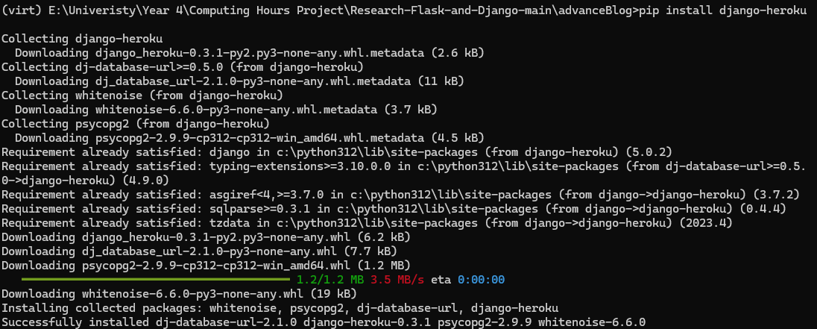

Figure 26 Heroku package

This package automates numerous routine tasks, including configuring static file handling, setting up database connections for Heroku's PostgreSQL service, and ensuring compatibility with the Heroku environment.

By integrating *django-heroku* into their projects, developers can guarantee that their Django applications are appropriately configured for deployment on Heroku. This not only saves valuable time but also minimizes the risk of configuration errors, enhancing the efficiency of the deployment process. Ultimately, this reinforces Heroku's reputation as a reliable platform for hosting Python web applications, regardless of whether they are built using Django or Flask.

To embark on deploying a Django and Flask application on Heroku, one can navigate through a series of methodical steps. Initially, it's imperative to ensure the Django application is meticulously configured, with a *requirements.txt* file, Figure NUMBER, encompassing all essential dependencies,



Figure 27 Requirements Install

alongside a *Procfile,* Figure NUMBER, delineating the web server command.

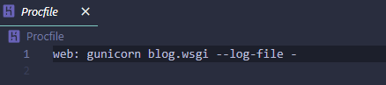

Figure 28 Procfile declaration

Subsequently, initiating a new Heroku application either through the Heroku CLI or the Heroku Dashboard sets the foundation. Connecting the local Git repository to the Heroku app and deploying the application by pushing the code to the Heroku remote repository initiates the deployment process. Heroku autonomously discerns the application type and undertakes any requisite build steps. Finally, scaling the application as necessary and ensuring that any requisite environment variables are aptly configured through the Heroku Dashboard, Figure NUMBER, or the Heroku CLI culminates the deployment journey.

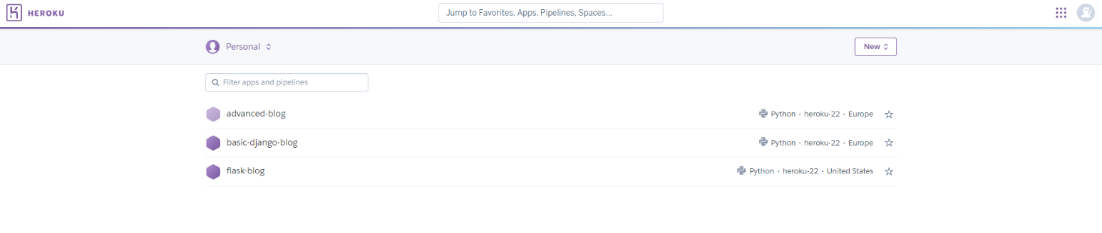

Figure 29 Heroku dashboard with current sites

## Conclusion

The comparison between Flask and Django within the realm of web development using Python has unveiled a myriad of insights, nuances, and considerations essential for developers and organizations venturing into web projects. Throughout the dissertation, various aspects of both frameworks were meticulously scrutinized, encompassing their philosophies, design principles, project structures, built-in features, community support, scalability, performance, learning curves, industry adoption, and security considerations. This systematic analysis has culminated in a comprehensive comprehension of the inherent strengths and weaknesses of Flask and Django, along with their suitability across diverse use cases and development scenarios.

Flask, distinguished by its minimalist approach and lightweight architecture, epitomizes the essence of "microframeworks," granting developers the liberty to architect applications with precision and efficiency. Its innate simplicity and flexibility render it an optimal choice for rapid prototyping, smaller projects, or contexts where customized solutions reign supreme. By relying on external libraries, Flask fosters modular development, empowering developers to tailor their stack to precise requirements and preferences. Nevertheless, this flexibility bears the potential for fragmentation, complexity, and maintenance challenges, particularly within larger and more intricate applications.

In contrast, Django embraces the "batteries-included" philosophy, furnishing a comprehensive suite of features and functionalities right out of the box. Equipped with built-in components for authentication, administration, ORM, and templating, Django streamlines the development process, empowering developers to concentrate on crafting high-quality applications sans the need for extensive configuration or integration of third-party tools. Its convention-over-configuration ethos fosters consistency, adherence to best practices, and rapid development, positioning it as an apt choice for large-scale, enterprise-grade projects with exacting requirements. Nonetheless, the opinionated nature of Django may impose constraints on developers accustomed to greater flexibility and customization, potentially inducing friction and trade-offs in select scenarios.

In the domain of community support and ecosystem maturity, both Flask and Django boast vibrant communities, exhaustive documentation, and rich repositories of third-party libraries, extensions, and plugins. This abundance of resources fosters learning, collaboration, and innovation within the Python web development community, empowering developers to harness existing solutions, share insights, and tackle common challenges adeptly. Moreover, the scalability and performance of both frameworks have been corroborated through diverse benchmarks and real-world deployments, substantiating their reliability, efficiency, and adaptability across varied workloads and traffic patterns.

The ultimate selection between Flask and Django hinges upon an array of factors, encompassing project requisites, development predilections, team proficiencies, scalability objectives, performance considerations, and long-term maintainability. While Flask thrives in its flexibility, simplicity, and aptness for smaller-scale projects or bespoke solutions, Django excels in its comprehensiveness, conventionality, and scalability for expansive, multifaceted applications. Thus, developers and organizations are urged to judiciously deliberate on these factors, grounding their decisions in the distinctive context, objectives, and constraints pertinent to their endeavours.

As the landscape of web development continues its evolution and diversification, Flask and Django persist as seminal pillars of the Python ecosystem, embodying the tenets of flexibility, pragmatism, and innovation. Whether embarking on novel projects, optimizing extant applications, or exploring emergent trends and technologies, developers stand poised to leverage the strengths and insights gleaned from this comparative analysis, navigating the intricacies of web development with poise, proficiency, and ingenuity.

In conclusion, the decision to build an advanced blog using Django is justified by its comprehensive feature set, conventionality, scalability, performance optimizations, and robust ecosystem support. By leveraging Django's strengths, developers can expedite the development process, maintain code quality, and ensure the long-term viability and success of the blog application in the ever-evolving landscape of web development.

# Advanced Blog – implementation

## Database Development

In designing the database schema for an advanced blogging application using Django's ORM, several models are created to capture various aspects of the application's functionality. The core models include *Category*, *Post*, and *Comments*, alongside integration with Django's built-in *User* model for managing user authentication and authorization.

The *Category model,* Figure NUMBER, serves to categorize posts, providing a structured way to organize content. It consists of a single field, *categoryName*, which stores the name of each category. This model enables users to browse and filter posts based on specific topics or themes. Additionally, the *get_absolute_url* method is implemented to facilitate navigation, directing users back to the home page after creating or updating a category.

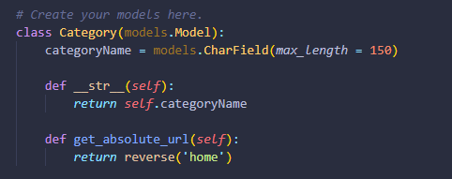

Figure 30 Advanced Blog - Category Model

In the Post model, Figure NUMBER, each blog post is represented with various attributes such as *author*, *title*, *tag*, *like*, *category*, *image*, *description*, *date_created*, and *date_updated*. The author field establishes a foreign key relationship with Django's User model, indicating the author of the post. This integration leverages Django's default user management system, enabling seamless authentication and access control within the application. Furthermore, the like field utilizes a many-to-many relationship with the User model, allowing users to express their appreciation for posts through likes.

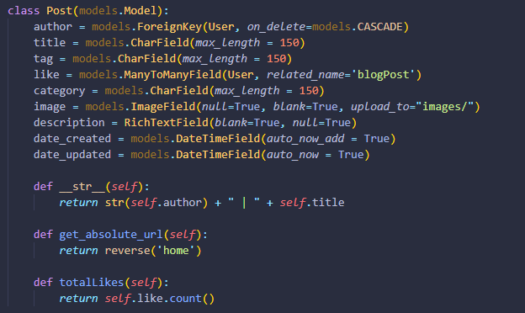

Figure 31Advanced Blog - Post Model

The Comments model, Figure NUMBER, facilitates user engagement by enabling comments on individual posts. Each comment is associated with a specific post through a foreign key relationship. The model includes fields such as name for the commenter's *name*, *comment* for the text content of the comment, and *date_created* to record the timestamp of comment creation. This structure encourages interaction and discussion among users, enhancing the overall user experience of the blogging platform.

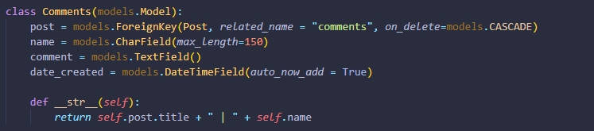

Figure 32 Advanced Blog - Comments Model

Integration with Django's default User model, Figure NUMBER, ensures robust user management capabilities within the application. By leveraging Django's authentication system, user registration, login, and access control functionalities are readily available. This integration simplifies the development process and enhances security, as Django provides built-in mechanisms for handling user authentication securely.



Figure 33 Advanced Blog - imported User Model

In summary, the database schema for the blogging application encompasses models for categorizing posts, representing individual posts, managing user comments, and leveraging Django's default User model for user authentication and authorization. This design enables the creation of a feature-rich and user-friendly blogging platform with robust user management capabilities.

## Authentication and Authorisation

In the Django application discussed, user authentication and authorization are managed primarily through Django's built-in authentication system. This system provides robust features for handling user authentication, including login, logout, password management, and user permissions.

### Authentication

When a user registers on the website, they provide necessary information such as username, email, first name, last name, and password. The registration form is implemented using Django's *UserCreationForm* along with a custom *RegistrationForm,* provided in a Figure NUMBER.

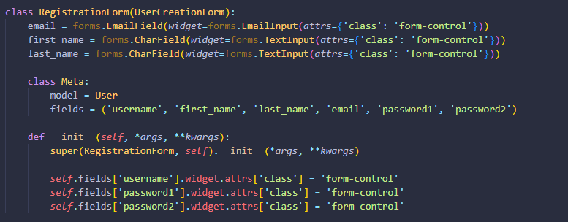

Figure 34 Authentication - registration form

This form ensures secure creation of user accounts and password hashing to maintain data integrity. Upon successful registration, a user is redirected to the login page. The *UserRegister* class Figure NUMBER, is a Django view that handles user registration functionality within a web application. It inherits from Django's *generic.CreateView*, which provides generic views for creating objects. By utilizing this class-based view, developers can quickly implement user registration without having to write extensive boilerplate code.

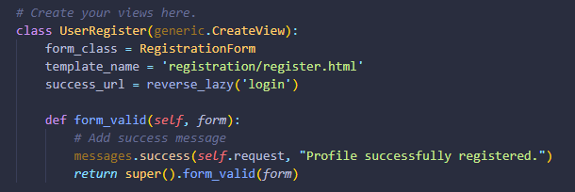

Figure 35 The registration view

Code provided in Figure NUMBER handles the registration process and displays appropriate success messages upon successful registration.

The registration form template, Figure NUMBER, is designed to collect user information and present it in a user-friendly manner. It utilizes HTML forms along with Django template tags to render form fields and handle form submissions securely.

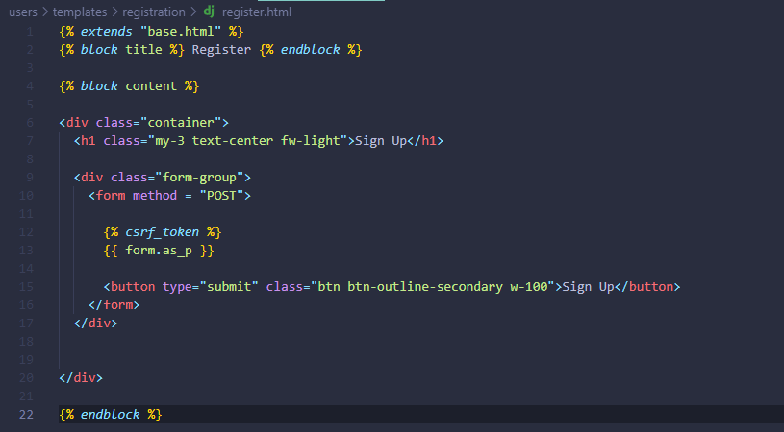

Figure 36 register.html

Upon successful registration, users are redirected to the login page where they can authenticate themselves using their username and password. The login form is implemented similarly to the registration form, utilizing Django's authentication system to verify user credentials.

### Authorisation

Authorization in the Django application governs the actions users can perform and the resources they can access. This is achieved through the assignment of permissions and user roles, providing fine-grained control over user privileges.

### Custom Implementation

Mention about Class in view

python -m pip install Pillow

# References

Adrian Holovaty, Jacob Kaplan-Moss, 2009. *The Definitive Guide to Django: Web Development Done Right (Expert's Voice in Web Development).* 2 ed. s.l.:Apress.

Bayer, M., n/d. *Mako Templates for Python.* [Online]   
Available at: https://www.makotemplates.org/  
[Accessed 28 02 2023].

Beck, K. B. M. v. B. A. C. A. C. W. F. M. .. &. K. J., 2001. *Manifesto for Agile Software Development.* [Online]   
Available at: https://agilemanifesto.org/  
[Accessed 30 12 2023].

Berners-Lee, S. T., 2000. *Weaving the Web: The Original Design and Ultimate Destiny of the World Wide Web.* s.l.:Harper Business.

Chesneau, B., 2023. *Gunicorn Documentation.* [Online]   
Available at: https://docs.gunicorn.org/en/stable/design.html  
[Accessed 29 02 2024].

Consulting, A., 2023. *The Pyramid Web Framework.* [Online]   
Available at: https://docs.pylonsproject.org/projects/pyramid/en/latest/  
[Accessed 28 02 2024].

Daniel Roy Greenfeld, Audrey Roy Greenfeld , 2021. *Two Scoops of Django 3.X: Best Practices for the Django Web Framework.* s.l.:Two Scoops Press.

Django, N/D. *Django Documentation.* [Online]   
Available at: https://docs.djangoproject.com/en/4.2/ref/templates/language/  
[Accessed 10 November 2023].

Duckett, J., 2011. *HTML and CSS: Design and Build Websites.* 1 ed. s.l.:Wiley.

Dwyer, G., 2016. *Flask By Example.* s.l.:Packt Publishing.

Eric Meyer, E. W., 2017. *CSS: The Definitive Guide - Visual Presentation for the Web..* 4 ed. s.l.:O′Reilly.

Frazier, M., 2023. *Flask-Login documentation.* [Online]   
Available at: https://pypi.org/project/Flask-Login/  
[Accessed 25 02 2023].

Frost, B., 2016. *Atomic Design by Brad Frost.* [Online]   
Available at: https://atomicdesign.bradfrost.com/  
[Accessed 06 03 2024].

GeeksForGeeks, N/D. *Flask-WTF Explained & How to Use it.* [Online]   
Available at: https://www.geeksforgeeks.org/flask-wtf-explained-how-to-use-it/  
[Accessed 25 02 2023].

Grinberg, M., 2018. *Flask Web Development: Developing Advanced Web Applications with Python.* 2 ed. s.l.:O′Reilly.

Hardt, D. C., 2012. *Internet Engineering Task Force (IETF).* [Online]   
Available at: https://datatracker.ietf.org/doc/html/rfc6749  
[Accessed 06 03 2024].

Haverbeke, M., 2018. *Eloquent Javascript, 3rd Edition: A Modern Introduction to Programming.* 3 ed. s.l.:No Starch Press,US.

Hellkamp, M., 2022. *Bottle: Python Web Framework.* [Online]   
Available at: https://bottlepy.org/docs/dev/index.html  
[Accessed 29 02 2024].

Karunanayake, Y., Feb 24, 2023. *Simple History of Programming Languages.* [Online]   
Available at: https://medium.com/@yureshcs/simple-history-of-programming-languages-db299d16b8e4  
[Accessed 02 01 2024].

Kevin Tatroe, P. M., 2020. *Programming PHP.* 4 ed. s.l.:O'Reilly Media, Inc..

Lolugu, K. V., 2023. *Let’s Code the User Experience.* [Online]   
Available at: https://bootcamp.uxdesign.cc/lets-code-the-user-experience-c47c72f50700  
[Accessed 30 10 2023].

Lutz, M., 2013. *Learning Python: Powerful Object-Oriented Programming.* 5 ed. s.l.:O′Reilly.

Marcotte, E., 2010. *Responsive Web Design.* 4 ed. s.l.:A Book Apart.

Martelli, A., 2006. *Python in a Nutshel.* s.l.:O′Reilly.

Martin Fowler, K. B. J. B. W. O. a. D. R., 1999. *Refactoring: Improving the Design of Existing Code..* s.l.:Addison-Wesley.

Matsumoto, Y., 2001. *Ruby in a Nutshell.* 1 ed. s.l.:O'Reilly Media.

Mcfarland, D., 2014. *JavaScript & jQuery: The Missing Manual.* 3 ed. s.l.:O'Reilly Media, Inc, USA.

Miller, I. D., 2017. *MVC: Model, View, Controller¶.* [Online]   
Available at: https://flask-diamond.readthedocs.io/en/latest/model-view-controller/  
[Accessed 27 01 2023].

MongoDb, I., 2021. *The MEAN Stack.* [Online]   
Available at: https://www.mongodb.com/mern-stack  
[Accessed 15 01 2024].

Obregon, A., 2023. *A Journey Through Time: The History of Java Programming Language.* [Online]   
Available at: https://medium.com/@AlexanderObregon/a-journey-through-time-the-history-of-java-programming-language-9b285d139333  
[Accessed 15 11 2023].

opentext, N/A. *What is Dynamic Application Security Testing (DAST)?.* [Online]   
Available at: https://www.opentext.com/what-is/dast#:~:text=By%20conducting%20DAST%20during%20the,damage%20to%20your%20brand%20reputation.  
[Accessed 05 03 2024].

OWASP, 2021. *OWASP Top Ten.* [Online]   
Available at: https://owasp.org/www-project-top-ten/  
[Accessed 06 03 2024].

Patrick Niemeyer, J. K., 2002. *Learning Java.* 2 ed. s.l.:Oreilly & Associates Inc.

Ramírez, S., N/D. *FastAPI.* [Online]   
Available at: ttps://fastapi.tiangolo.com/  
[Accessed 06 03 2024].

Richardson, C., 2019. *Microservice Patterns.* 1 ed. s.l.:Manning Publications.

Robbins, J. N., 2018. *Learning Web Design.* 5 ed. s.l.:O'Reilly Media, Inc, USA.

Ronacher, A., 2010. *Design Decisions in Flask.* [Online]   
Available at: https://flask.palletsprojects.com/en/2.3.x/design/  
[Accessed 11 11 2023].

Ronacher, A., 2024. *Flask Documentation.* [Online]   
Available at: https://flask.palletsprojects.com/en/3.0.x/  
[Accessed 01 03 2024].

Ronacher, A., n/d. *Jinja Documentation.* [Online]   
Available at: https://jinja.palletsprojects.com/en/3.1.x/  
[Accessed 29 02 2024].

Rose, S., 2020. *A Complete Guide to the Back-End Mobile App Development!.* [Online]   
Available at: https://codeburst.io/a-complete-guide-to-the-back-end-mobile-app-development-9609f5979231  
[Accessed 14 01 2024].

Rossum, G. v., 2009. *A Brief Timeline of Python.* [Online]   
Available at: https://python-history.blogspot.com/2009/01/brief-timeline-of-python.html   
[Accessed 15 11 2023].

Sharma, R., 2023. *Best Practices for Front-End and Back-End Integration in Full Stack Development.* [Online]   
Available at: https://medium.com/@rishani.ynr/best-practices-for-front-end-and-back-end-integration-in-full-stack-development-bbd21b36399c   
[Accessed 05 11 2023].

Sheffer, U., 2015. Recommendations for Secure Use of Transport Layer Security (TLS). *Internet Engineering Task Force (IETF),* Volume 2070-1721 , p. 26.

Stroustrup, B., N/A. *Bjarne Stroustrup's homepage!.* [Online]   
Available at: http://www.stroustrup.com/  
[Accessed 21 11 2023].

Team, E., 2022. *Guido van Rossum: The Father of Python.* [Online]   
Available at: https://enki.tech/guido-van-rossum-the-father-of-python/  
[Accessed 21 11 2023].

Vincent, W. S., 2020. *Django for Beginners: Build Websites with Python and Django: 1 (Welcome to Django).* s.l.:WelcomeToCode.